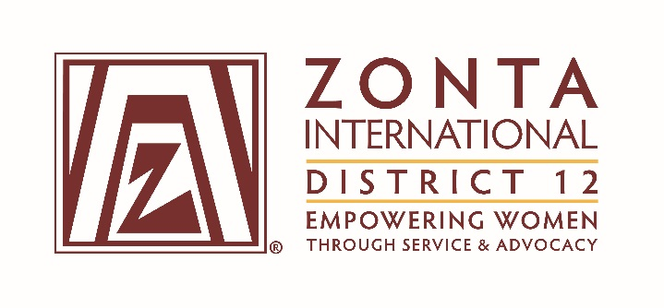

January 7, 2017 Leadership Team Reports

Name: Judy McNerny
Position / Committee: Jane M. Klausman Women in Business Scholarship Coordinator
Goals: [cut and paste from what was submitted]
Goal | Deadline
- Recruit judges for 2016 award | June 30, 2016
- Complete my goals for the biennium | July 15, 2016
- With Webmaster’s assistance, update District website | July 31, 2016
- Talk personally to each club president (or contact named by club president) to encourage clubs to:  - Investigate local schools  - Offer a monetary JMK award  - Solicit applications for the District scholarship | November 30, 2016
- Work with the Foundation Ambassador and Area Directors to solicit funds for the JMK District Scholarship at every Area Meeting during the biennium | April 30, 2017 and  April 30, 2018
- Increase the number of clubs offering a scholarship from 7 to 9 by the end of the biennium | May 31, 2018
- Increase the number of clubs submitting an application for the District Scholarship from 6 to 8 by the end of the biennium | July 1, 2018

Accomplishments (to date) & plans for next 6 months.

I achieved the first three goals in a timely fashion.

I have begun talking with club presidents, but have not achieved goal four yet. I will continue to work on this one and have a January 31 goal for that.

The deadlines for goals 5, 6 and 7 are in the future and during the next six months I will be working on these. I have begun working on goal 5. I hope to attend the Area 2, 3 and 4 area meetings (probably not Area 1) and lobby club presidents at those meetings to help achieve goals 6 and 7.

Questions for Governor report: (Respond if apply to you. You may delete the parts that don’t apply to you.)

- What have been your district’s successes / achievements since the beginning of the biennium?
We awarded a District JMK Scholarship and our winner was selected to receive an International scholarship as well.

- What challenges have you encountered since the beginning of the biennium?
Making contact with club presidents has been more difficult than I anticipated.

- What guidance or information is needed from the ZI level for your district and clubs to achieve the biennial goals that concern them?

I have become aware of an interpretation of the JMK guidelines at the ZI level that is not clear from the written guidelines; namely, that an applicant must attend school in the area where the club is located and that being a resident of that area is not sufficient. I plan to contact ZI about this, unless it would be preferable for the Governor to do so.

- What do you, your district or club members need help with? (Can be from liaison, board, HQ.)
The idea has occurred to me that clubs without funds to offer a significant scholarship at the club level might seek a corporate sponsor from the community for their scholarship. Would this be acceptable?

