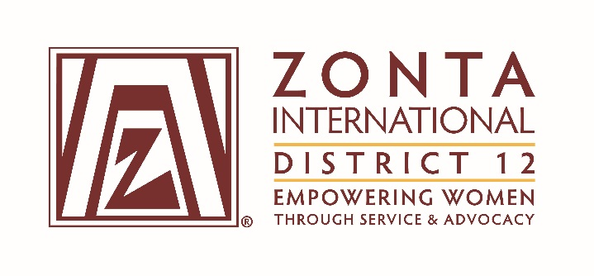

January 7, 2017 Leadership Team Reports

Name: Mary Benoit
Position / Committee: Foundation Ambassador
Goals: [cut and paste from what was submitted]

Contact all club presidents by 9/1/16.
Increase donations to the Foundation by 10% by the end of the biennium. Increase individual donations by 10% by the end of the biennium.
Work to insure all clubs in the district donate to the Foundation.
Become knowledgeable about the ZI service projects and ZISVAW projects. Pass this knowledge on to the clubs.
Distribute the posters for the projects to the clubs.
Report on District 12 clubs and individual donations to ZI Foundation. This will be numbers only, no names will be mentioned. Report on the status of District 12 in relation to the rest of the districts.
Encourage individual donations. Coach clubs on fund raising events that emphasize individual donations. Emphasize the importance of first time donors.
Communicate with membership chairs making sure that new members understand that they are joining an international organization and the club they are joining has an obligation to support the foundation and the International projects. Also to communicate that it is an expectation that members donate individually.

Accomplishments (to date) & plans for next 6 months.

Attended the Governor’s Seminar, gave a presentation about the foundation and the service projects. Did fundraising at the Governor’s Seminar.

I have sent personal thank you notes to everyone that has made a contribution to the Foundation. I will continue to do so.

I sent a letter and donation forms to all club presidents and club foundation ambassadors if they were listed in the directory. I encouraged donations for the Every Member Every November campaign. I asked that club presidents appoint a foundation ambassador if they didn’t already have one.

NEXT 6 MONTHS

Examine my goals and work on those that have not been worked on.

Attend Area Meetings.

Questions for Governor report: (Respond if apply to you. You may delete the parts that don’t apply to you.)

- What have been your district’s successes / achievements since the beginning of the biennium?
The Governor’s Seminar was very successful. We raised $320 with the 50-50 drawing. This worked very well because the winner donated her winnings back to the Foundation. Kay Meyer donated a book and auctioned it off for $165.00.

- What challenges have you encountered since the beginning of the biennium?
The biggest challenge is communication. I have contacted all club presidents about the foundation and only 1 or 2 have responded. The mistake I made was I didn’t copy the Area Directors.

- What guidance or information is needed from the ZI level for your district and clubs to achieve the biennial goals that concern them?

ZI has been great about education around fund raising and the service projects. We had a webinar regarding the project in Madagascar on November 18th and now there is a slide show on the project that is available.

- What do you, your district or club members need help with? (Can be from liaison, board, HQ.)
I need help in communicating with the clubs.

- Is there anything else you would like to address?

