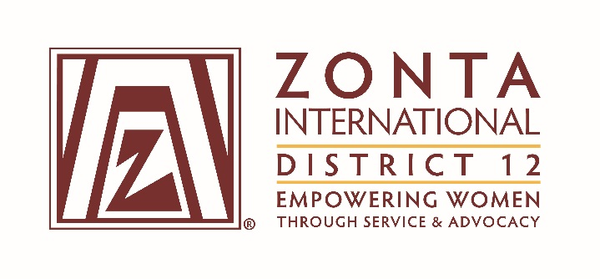

January 7, 2017 Leadership Team Reports

Name: DENISE PARRISH
Position / Committee: UNITED NATIONS AND ADVOCACY COMMITTEE CHAIR
Goals: [cut and paste from what was submitted]

Goal: We are prominent advocates to advance and uphold women’s rights to be free from gender discrimination and inequality, allowing women to reach their full potential while living without fear of violence or exploitation.

Objectives and Indicators
• Assist in educating the area leaders, club leaders, and club members about Advocacy, and how the advocate work being done at the local level is consistent with and part of the bigger picture of the work of Zonta International and its international partners
▫ Seek to have at least one appointee to the Advocacy / UN Committee from each of the four states in the district no later than August 15th; each of these appointees, along with the area directors, should assist with the Advocacy education and identification of Advocacy opportunities in their respective state

▫ Prepare and provide an Advocacy/UN themed article for each edition of the District 12 Outlook

▫ Offer to provide an Advocacy / UN presentation or update or break-out session for each area meeting and for the District 12 conference/seminar

▫ Encourage clubs to share their Advocacy work and experiences so that clubs learn from each other’s experiences with sharing through conversation, meetings, social media, club websites, and other means.

• Work with area leaders and club leaders to ensure that Advocacy and United Nations Initiatives are being included in the priorities and activities of the District 12 clubs
▫ No later than October 1st of each year, identify each club’s Advocacy Committee chair

▫ Ensure that at least once each year, a member of the District 12 Advocacy / UN Committee interacts either in person or through conversation with the Advocacy chair of the each of the clubs and with the area director or vice-director for that Club

▫ No later than September 1st of each year, review each club’s Advocacy work for the past year and select the recipient of the District’s Advocacy award to be given at the Governor’s Conference/Seminar

• Develop information and examples that will help Areas and Clubs to begin implementation of the UN Sustainable Goal #5 to achieve gender equality and empower all women and girls in meaningful and achievable ways for their own locales and circumstances
▫ Identify no less than 3 and no more than 5 focused target Advocacy projects by October 1st of each year that will become the suggested (but not mandated) projects for District 12 clubs to engage in during the course of the biennium; consultation with the District 12 Service Committee Chair should occur during the development of the project list
Examples of projects might be enacting Women’s Empowerment Principles or Ending Human Trafficking

▫ Relative to each of the identified target projects, provide the Area Directors and club leaders simplified, actionable information that provides a variety of ways that the Advocacy for a particular topic could be approached – providing information on at least two project no later than November 15th and the remainder no later than February 15th of each year.

Accomplishments (to date) & plans for next 6 months.

Questions for Governor report: (Respond if apply to you. You may delete the parts that don’t apply to you.)

- What have been your district’s successes / achievements since the beginning of the biennium?
I was able to get the name of one person from each of the four states to be the Advocacy point person for that state.
I wrote an article about my goals for the October newsletter, including the areas upon which I intend to focus (child bride, age of consent, equal employment opportunities, human trafficking, domestic violence)
I am on the agenda for the Area 3 meeting in January and will discuss Advocacy matters.
I will be on the agenda for the Area 2 meeting in April and will discuss Advocacy matters. (I am also seeking to be on the agenda for the other two area meetings.)
I have prepared two discussion starter flyers: one on Child Brides in America and one on the Age of Consent and asked them to be placed on the District website (which as been done) and shared them with Area Directors. (More needs to be done to share these and discuss how they can be used).
I have spent time researching some of the bills being introduced in each of the four states and am beginning to prepare (but more work is needed) on the legislative watch. Especially important to share and watch are some of the Montana sentencing bills that are being introduced.

- What challenges have you encountered since the beginning of the biennium?
Getting a team together with a point of contact from each state took longer than expected, and then I have not been in touch with these people on a regular basis as I hoped to be.
Frankly, it took a while for me to get engaged in and jump start my thoughts and work on District Advocacy. Now that I am starting to figure out what messages I wish to share, I need to work at building a means of communicating messages. Much of what I have been doing is educating myself rather than working closely with the Area Directors and the Clubs.

- What guidance or information is needed from the ZI level for your district and clubs to achieve the biennial goals that concern them?

Nothing specifically that I can think of right now.
I am planning to attend several days (based on financial support from my Club) of the UN Commission on the Status of Women in New York in March. I hope to be able to get additional ideas (and motivation) on how to promote discussion and action on some of the focal topics identified for attention this biennium.

- What do you, your district or club members need help with? (Can be from liaison, board, HQ.)
Nothing specific right now.

- Is there anything else you would like to address?
I appreciate the patience of the more experienced leaders of District 12 while I have felt my way through the early period of this biennium. I hope that I will be able to make a greater contribution to the discussion than I have made so far.

