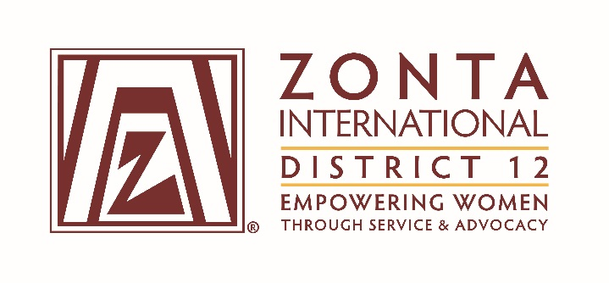

January 7, 2017 Leadership Team Reports

Name: Sheila Davis
Position / Committee: Leadership Training
Goals:
Leadership skills and competencies are increased at all levels

Objectives & Indicators:

- Leadership training programs are conducted for District 12 members

  - Classes will be provided throughout the biennium based upon needs of the members
  - Evaluations will be developed and conducted to assess the effectiveness of the training beginning January 1, 2017

  - A training improvement plan to increase the effectiveness of classes will be created by August 31, 2017

  - Improvements will be implemented by December 31, 2017

- Online training will be examined and a blended training implementation plan created

  - A plan for online training will be created by December 31, 2017

  - One pilot online training class will be delivered by May 31, 2018

Accomplishments (to date) & plans for next 6 months.

The following classes were given:
Area Director Training
Club Secretary

Evaluations for several classes were done. Good suggestions for online training were given.

The following classes are planned:
Jan 2017 - Area Meeting Training
Jan 2017 - Voices for Gender Equality/Young Professional Program
Feb 2017 - CSW61
Mar 2017 - Club Nominating Committee
Apr/May 2017:
Club President & VP
Club Secretary
Club Treasurer
Club Board

A trial of additional tools including but not limited to GoToMeeting, Signup Genius, Zoom, & ZI LMS will begin January 1, 2017.

Evaluations will be done for all classes through May 2017.

An assessment of the evaluations will be completed by August 1, 2017.

A training improvement plan to increase the effectiveness of classes will be created by August 31, 2017.

Questions for Governor report: (Respond if apply to you. You may delete the parts that don’t apply to you.)

- What have been your district’s successes / achievements since the beginning of the biennium?
See above completed classes. Also, the evaluation process has been extremely beneficial in identifying the criteria for future training including both online and virtual training.

- What challenges have you encountered since the beginning of the biennium?
Determining the best avenues and formats for training including classroom, online, and virtual are still underway as we had a late start to the training for current positions. Buying and trialing tools has taken longer than expected.

