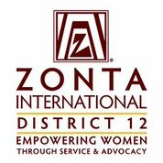

January 7, 2017 Leadership Team Reports

Ann Hodgson/Amelia Earhart Coordinator
Goals:
- Contact four universities to find out if they have programs that would have applicants.
- Increase D12 number of AE applicants by one each year.
- Invite past and current AE Fellow who live in the District to 2 club meetings a year.
- Provide materials to all D12 clubs for an AE focused event in January each year.

Accomplishments:
- Contacted Colorado School of Mines, UCCS, University of Wyoming, University of South Dakota
- Attended CU meeting of women Aerospace students, spoke about the Fellowships and handed out applications. No measurement available yet.
- Obtained list from ZI and am working on contacting past Fellows.
- Sent email with ZI information and suggestions to all club presidents in the fall of 2016.
Questions for Governor’s Report:
- NA
- None
- None
- Better results to searches of ZI websites. One problem is that searches don’t go across the various websites and it’s hard to figure out where you should be to make the search.
- No

