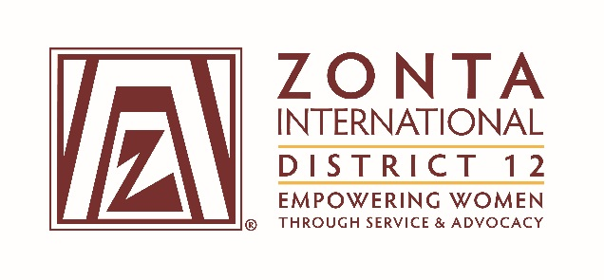

2016 Transitional Leadership Team Meeting
Holiday Inn Express Hotel
900 W. Yellowstone Highway
Douglas, WY
June 3 - 5, 2016

2014-2016 Board& Committee Chair Reports

Name: Jan Kirch

Position / Committee: District 12 ZIF Ambassador

Goals:
- Donations to Zonta International foundation increase by 5% from previous biennium.

- Individual donations to the Foundation will increase by 10% from previous biennium.

- 100% of D12 Clubs will contribute to Zonta International Foundation.

- Partner with clubs (and D12 committee) to encourage active promotion and public relations of ZIF by:
  - Ensuring every club has an appointed ambassador, a ZIF power point presentation, and an international service project poster file by December, 2014 to use in their clubs

  - Encouraging each club to continue the potluck fund raising (or similar) events to highlight the ZIF projects and to raise funds.

  - Attend the 2015 District Conference, and all Area Meetings during this biennium to present Foundation information

  - Reporting ZIF contribution data to all members every two months through the D12 website & the Outreach

- Provide each club in the district with a U-Tube presentation of the different ways to support ZIF. To include:
  - Good search
  - Good shop
  - Smile Amazon accounts

Accomplishments

- Accomplishments:

Emailed Club Presidents or appointed Club ZIF Ambassadors with Contribution Reports

Forwarded ZIF Service Project Updates to Club Presidents

Created a new U-Tube video about Ways to Give to ZIF.

Attended the D12 Conference and presented the newVideo to members.

Attended Area meetings and Club meetings in my Area during the biennium to
present ZIF updates, and shared the Video with members,
encouraging them to donate

As of 04-30-16:
D12 has contributed $156,360.73 which is 3% increase from the last biennium
(average $279.72 per member)

Individual contributions total $35,491.41 which is 3% increase this biennium
(263 members out of 559 total contributed or 47% of members)
(D12 ranks 4th out of all Districts for % of members donating)

100% of District 12 Clubs have made contributions to ZIF

- Plans:

  - Contact each incoming Club President in June to request that they appoint a
Club ZIF Ambassador or other appointee

Forward each ZIF Service Project Update & Videos to the Club Representative
to share with their members

Ask each Club Representative to plan a separate ZIF fund raiser on or before the month
of November to accomplish the Every Member Every November campaign goal

Forward the ZIF Powerpoint presentation to the Club Representatives by July 15th
to assist them in fundraising

Make plans to attend a ZIF Fund Raising Event at the Clubs in your Area. Ask the
Area Vice Directors or other Leadership Team members to assist by
attending a ZIF Fund Raising Event in their Areas

Encourage each Club to help us reach our ZIF goals for the biennium.

What worked well?
Attending the Area Meetings worked – ZIF updates readily received. Attending Club Meetings in my Area worked well also. The Clubs appreciated the ZIF updates, and appreciated the U-Tube Video.

What would you change?
Encourage Clubs to give 1/3 of their funds raised to ZIF. Utilize Club Foundation Ambassadors to share international project updates and videos, and encourageEvery Member Every November campaigns.

