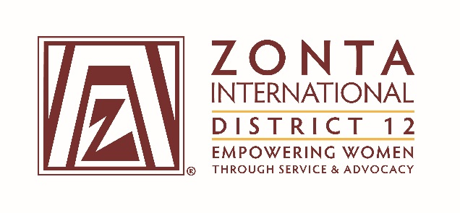

2016 Transitional Leadership Team Meeting
Holiday Inn Express Hotel
900 W. Yellowstone Highway
Douglas, WY
June 3 - 5, 2016

2014-2016 Board & Committee Chair Reports

Name: (Deedee Boysen)

Position / Committee: Z and Golden Z Club Coordinator

Goals:
Z and Golden Z Coordinator
- Create and maintain a contact list of Z and Golden Z Clubs and Advisors in District 12.
- Create a training program for District 12 Zonta Clubs interested in forming a new Z or Golden Z Club or submitting an application for the Emma L. Conlon Award.
- Provide articles on new or continuing Z and Golden Z Clubs to the Outreach and to ZI as requested.
- Forward articles from Zonta International to the Z Clubs.
- Participated in all Z or Golden Z Club Chartering events.
- Provide support to clubs interested in forming new Z or Golden Z Clubs.

Accomplishments (For the Full biennium (2014 – 2016); be specific as this is intended to be final report AND assist the incoming person taking the position).

- Accomplishments:
  - A contact list was developed and maintained throughout the biennium, with updates added as needed.
  - Powerpoint presentations were developed on the Emma L. Conlon Award, and Forming a Z or Golden Z Club. A program was also presented at the District 12 Conference on District Z Club accomplishments.
  - A new Z Club, the Poudre High School Zonta Z International Leadership Club, was chartered in Ft. Collins, CO in 2015.
  - A new Golden Z Club, the Flatirons Golden Z Club, was charted in Boulder, Co by the Foothills Club in 2016.
  - Articles on Z and Golden Z Clubs were provided to the Outreach bi-annually.
  - The Laramie High School Z Club took Second Place in the Emma L. Conlon Service Award competition in 2014 and First Place in the competition in 2015.
  - Two new Z Clubs, one in Greeley and possibly one in Cheyenne are in the process of forming in the next biennium. Telephone support was provided to the Greeley Club on several occasions and a presentation was made to the Greeley Club in 2015 on forming a new Z or Golden Z Club.

- Plans:
  - Transfer all relevant materials, both digitally and in hard copy, to the 2016 - 2018 Z and Golden Z Coordinator. That has already been accomplished.
  - Provide continuing support to the 2016 - 2018 District 12 Z and Golden Z Coordinator as requested.

What worked well? (For the Full biennium (2014 – 2016); be specific as this is intended to be final report AND assist the incoming person taking the position).
- Training sessions for the topics associated with Z and Golden Z Clubs were sporadically attended, even when personal invitations were extended. That was a good start however, and provided a foundation for getting to know the advisors and they to know a Coordinator existed in the District and was available to help them.
- Personal visits/contacts with the advisors or with the Z Clubs were terrific. If time and resources had permitted, I would have liked to meet with all the advisors either personally or via conference call. It would have been nice to get them together for information sharing. Traveling to attend the chartering celebrations was time well spent and provided opportunities to meet the club members, along with the advisors, and gather both information and photos of the events... which were shared in Outreach articles.
- I thought the presentation on our District Z and Golden Z Clubs at the District Conference was well received, and inviting the Z Clubs to bring their members at a reduced rate for one day was a great first step to involving these wonderful young women in Zonta. It would be great to take this to the next level by offering a few workshops for them as an extra track at the next District Conference. Even better... invite them to lead the workshops for their peers or help with the planning. I know there is some interest in doing that.

What would you change? (For the Full biennium (2014 – 2016); be specific as this is intended to be final report AND assist the incoming person taking the position).
- I wish I had been more persistent in tracking down the advisors and getting them together. Perhaps that can be accomplished by the next coordinator. I feel there is a tremendous benefit for them to meet and discuss what works and what doesn't in their Z Clubs. So, more communication.
- Knowing what I do now, I would increase my efforts to reach out to club leaders in a more organized approach... perhaps by contacting all the club presidents at least once in the biennium regarding their interest in forming new Z or Golden Z Clubs in the District and by learning more about the existing clubs.
- If I had more time, I would have liked to help promote the clubs more often in the District newsletter and through the ZI Z and Golden Z Facebook page. Perhaps we could get something going in our District and at least get the advisors to like the other clubs' Facebook pages. So, more publicity/visibility.

