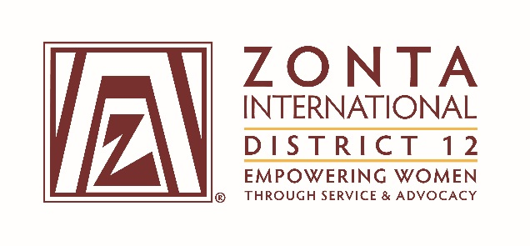

2016 Transitional Leadership Team Meeting
Holiday Inn Express Hotel
900 W. Yellowstone Highway
Douglas, WY
June 3 - 5, 2016

2014-2016 Board& Committee Chair Reports

Name: Ann Hefenieder

Position / Committee: Service Chair

Goals:
1. Local projects are in line with Zonta International’s mission and vision.
Measures:
● 100 % of all local projects focus on women’s and girls issues
●Cooperative projects undertaken only with like-minded organizations.

2. Select annual District Service Award winner for recognition at 2014 Governor’s Seminar and 2015 District Conference
Measures:
✔ Announcement of annual winners

3. Improve club annual reporting regarding service projects to insure that all clubs known and understand the Zonta International goals, award criteria and submit complete reports.
Measures:
✔ Prepare articles for the Outreach newsletter during biennium
✔Reach out to clubs with information regarding ZI goals, District Service Award criteria
✔ Encourage club service chairs to assist club presidents in preparation of annual report as to service

4. Attend meetings as shown in the Board & Committee Chair Meetings & Conference Calls document
Measures:
✔ Attendance at meetings

5. Coordinate, at the District level, activities to implement service programs authorized by the International Convention or by Zonta International.
Measures:
● Developed as needed as ZI programs are announced

6. Cooperate with the District Advocacy and United Nations Committees.
Measures:
✔ Worked with Advocacy on the District Service Project

7. Act as the liaison between International Service Chair and each
Club Service Chair and shall maintain contact with both.
✔ Pass along e-mails as appropriate
✔ Respond to requests for information/assistance

8. From club annual reports, tabulate total dollars raised and given out for the District and for each Area.
Measures:
✔ Report to Governor or designee in advance of Governor’s Seminar and District Conference

9. Coordinate District Service Project
Measures:
✔ Project announced at Governor’s Seminar and District Conference
✔ Follow up with club service chairs regarding participation

Accomplishments

1. Prepared multiple Outreach articles regarding ZI District 12 Service Project (coordinating with Advocacy) for clubs and District Service Award criteria.
2. Prepared Report for sharing at D-12 area meetings, spring 2016.
3. Responded to Club inquiries about ZI Award guidelines, district service award guidelines, and miscellaneous topics and assistance requests.
4. District Service Awards given at 2014 Governor’s Conference and 2015 District Conference.
5. Prepared and submitted D12 District Service Project to ZI for consideration.

What worked well?
1. Information sharing – if persons asked for information by e-mail, that was the way to respond. Otherwise, many Zontians do not read e-mails from Zonta or D-12, I have discovered. The best way to relay critical information is in person, either by presentation or one-to-one phone call.

2. “Zonta Says No” really took hold. Encourage clubs to continue projects that incorporate this program
and relay that information to the “powers that be” at ZI.

What would you change?
1. Ask for volunteers EARLY and often. Get a service committee with a state volunteer for each state in the District, and get them involved immediately in reviewing club service reports for the annual convention D-12 service award. Ask Area Directors and Vice Area Directors for suggestions of names of willing volunteers in each state, and then make the ask yourself, in person/by phone.

2. Push for greater involvement in the selection of a D-12 service project. The Governor should ask for your input early and often. Keep in mind that not every club will be willing/able to participate, but don’t get discouraged. Keep encouraging participation, and help brainstorm with clubs that have issue with a directive.

