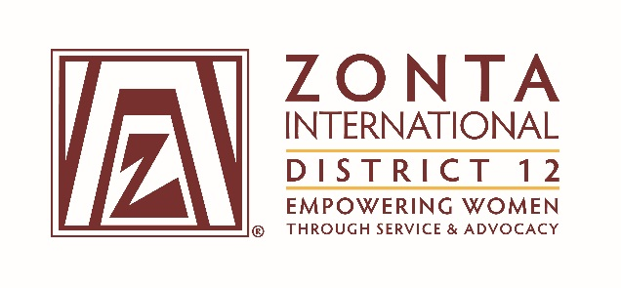

2016 Transitional Leadership Team Meeting
Holiday Inn Express Hotel
900 W. Yellowstone Highway
Douglas, WY
June 3 - 5, 2016

2014-2016 Board & Committee Chair Reports

Name: (Deedee Boysen)

Position / Committee: District Secretary

Goals:
Secretary
- Take the minutes of the Governor's Seminar (September 2014) and the D12 Conference (September 2015)
- Take the minutes of the Board Meetings at the Transitional Board Meeting (June 2014 and June 2016), the Governor's Seminar (September 2014), the Winter Board Meeting (January 2015 and January 2016), and the Summer Board Meeting (June 2015).
- Offer training sessions to clubs on the Club Secretary Responsibilities and Duties.
- Perform duties as requested by the Governor.

Accomplishments (For the Full biennium (2014 – 2016); be specific as this is intended to be final report AND assist the incoming person taking the position).

- Accomplishments:
  - Minutes were taken for the 2014 Governor's Seminar and the 2015 District 12 Conference.
  - Minutes were taken for the 2014 and 2016 Transitional Board Meeting, the 2014 Board Meeting at the Governor's Seminar, the 2015 and 2016 Winter Board Meeting, the 2015 Board Meeting at the District 12 Conference, and the 2015 Summer Board Meeting.
  - Four Club Secretary Training Sessions were offered. There were 3 training sessions in 2015 and 1 session in 2016.
  - Support was provided to the Governor throughout the biennium, primarily in the form of support for meeting logistics.

- Plans:
  - Transfer all secretary materials to the incoming 2016 - 2018 secretary both digitally and in hard copy format. This has already been accomplished.
  - Provide continuing support to the 2016 - 2018 District 12 Secretary as requested.

What worked well? (For the Full biennium (2014 – 2016); be specific as this is intended to be final report AND assist the incoming person taking the position).
- Training sessions for club secretaries had low attendance, but the fact that there were 1-4 participants each time indicated that a need for this type of training in the District existed. Presentation materials were posted on the website prior to the training sessions so others who couldn't attend on specified dates could access the materials as resources.
- All meeting minutes were provided to the Governor for review within two weeks following each event.
- I really liked the format and materials that were passed on to me by the previous District Secretary.

What would you change? (For the Full biennium (2014 – 2016); be specific as this is intended to be final report AND assist the incoming person taking the position).
- Training sessions were well publicized via the Internal Communications Chair, even with targeted marketing to Club Secretaries. I believe these training sessions could have been further promoted by the Area Directors with encouragement to Presidents to remind their Club Secretaries of the value of attending.
- It would be great to pass on a zip drive and hard copy of the biennium meeting minutes without the cumbersome addition of 3-4 boxes of secretarial history that went with them. Perhaps these notebooks (or some of the older ones) would be better off residing with the District Historian rather than being stored with the current District Secretary for two years. And hopefully the Historian will find a permanent place for her boxes, along with the Secretary's in the upcoming biennium.

