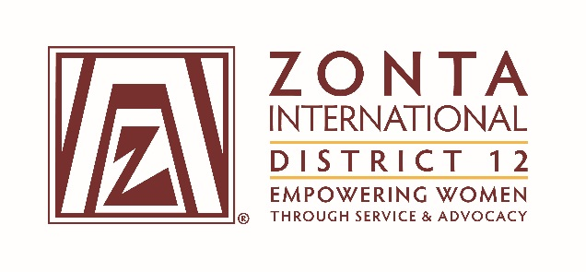

2016 Transitional Leadership Team Meeting
Holiday Inn Express Hotel
900 W. Yellowstone Highway
Douglas, WY
June 3 - 5, 2016

2014-2016 Board & Committee Chair Reports

Name: Reneé Coppock

Position / Committee: Membership

Goals: Membership

Goal:Clubs recruit and retain committed and skilled members

Objectives & Indicators:

- Achieveanetincreaseinthenumberofmemberseachbiennium

- Add 1 net new member to each club in 2014-2015 & in 2015-2016

- Hold monthly/bimonthly conference calls with Vice Area Directors

- Send out a monthly summary of current & yearly goal membership numbers to each club

- One new club of committed members is chartered each year

- Form E-club by end 2015

- Complete geographic location analysis of 2-3 locations for club by end 2015.

- The number of disbandment of clubs is decreased by 5%.

- No clubs disband in District 12 during biennium

- Club presidents report increased level of active member participation

- Add 1 net new member to each club in 2014-2015 & in 2015-2016

- Club presidents report that the necessary level of skills and competencies are represented in the club

- Provide leadership training for club positions of President, Vice President, Treasurer, Secretary and Board of Directors by May, 2015 and by May, 2016, if not otherwise conducted.

Accomplishments (For the Full biennium (2014 – 2016); be specific as this is intended to be final report AND assist the incoming person taking the position).

- Accomplishments:
  - Membership:
    - Conducted conference calls with Membership Team. However, for 2016, Team members were difficult to organize
    - Sent out net +1 numbers and called clubs that have no or negative growth
    - Surveyed the Club presidents to determine what type of training clubs need
    - Selected SOM – Zonta Club of Blackhills—to charter an e-club. Had 13 committed members. May be closer to 10 at the present time.
  - Membership numbers by Area are attached
  - Took a general survey of towns that may be suitable for starting a new club. Bozeman, MT is promising.

- Plans:
  - To assist Deedee in getting the SOM functioning again and form that e-club.

What worked well? (For the Full biennium (2014 – 2016); be specific as this is intended to be final report AND assist the incoming person taking the position).
  - The telephone calls with the Vice Area Directors also included membership chairs and presidents, if they wanted to join in. That was very helpful and we could share a lot of ideas and questions could be answered.
  - Getting a larger club to work as SOM works, as there are more members to carry the load.
  - Sending out membership numbers as they arrived from ZI gave clubs an indication of where they were with regard to the goals.

What would you change? (For the Full biennium (2014 – 2016); be specific as this is intended to be final report AND assist the incoming person taking the position).
  - I would hold the telephone conferences on a specific day each month, regardless if half the people indicated that they could not attend.
  - Not visiting the SOM club and making a detailed time line and budget for the club.
  - ZI and District membership numbers still do not match very often.

