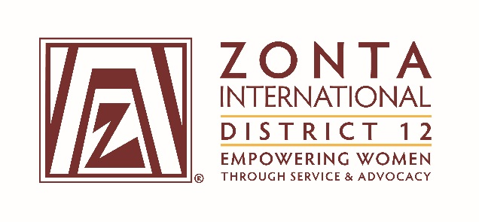

2016 Transitional Leadership Team Meeting
Holiday Inn Express Hotel
900 W. Yellowstone Highway
Douglas, WY
June 3 - 5, 2016

2014-2016 Board& Committee Chair Reports

Name: Kari Winter

Position / Committee:Internal Communications Chair

Goals/Objectives:
- June-Aug 2014 collect D12 officer and committee updates for directory (including pictures). Collect and update club members(add new members, remove those not renewing membership)and club committees.
- Shortly before Governor’s Seminar/D12 Conference: Obtain orders for hard copy directories, have directories printed.
- Distribute an updated District 12 directory at the 2014 Governor’s Seminar and 2015 District Conference.
- Update club and committee distribution list with member changes received throughout June-August.
- Throughout the year, continue to update directory as new information is received and provide an updated electronic directory to the District 12 webmaster on a bi-monthly basis.
- Keep current email lists of District 12 members and update information received within 5 days of receipt.
- Forward communication message to District 12 members as requested. Ensure messages are delivered within 2 days of receipt.
- Follow-up on bounced emails with club presidents to get updated email addresses.
- Research potential ways to update the directory and email distribution list through the use of an online tool. Provide options and recommendation to District Board at the January 5th conference call.

Accomplishments (For the Full biennium (2014 – 2016); be specific as this is intended to be final report AND assist the incoming person taking the position).

- Accomplishments:
  - D12 Club officer and committee information updated. Club member and committee information updated between June-August.
  - Club orders for directories collected prior to Seminar/Conference.
  - Distributed directories at Seminar/Conference and mailed directories to clubs not in attendance.
  - Updated club and committee distribution list June-August.
  - Continued to make updates to the directory and distribution lists throughout the year as member updates are received. This was not always done within 5 days of receipt (more like monthly/bi-monthly) due to time constraints/other priorities.
  - Prior to the move to Mailchimp, I followed up on bounced emails almost immediately. Post move to Mailchimp, I have only done this a few times. I haven’t had time to go back into the tool and review bounced information and correspond with presidents.
  - Moved distribution list and communication message delivery from Outlook to Mailchimp in September 2015. In March of 2016, moved from multiple distribution list to one large distribution list with segments to save time and better utilize tool features.
  - Created email communication guidelines document and documented position responsibilities in detail.

- Plans:
  - Transition role to new incoming board member.

What worked well?(For the Full biennium (2014 – 2016); be specific as this is intended to be final report AND assist the incoming person taking the position).
- XYZ:
  - After moving to Mailchimp, the communication messages look more professional.
  - Updating member information is easier and more efficient in Mailchimp than it was in Outlook.

What would you change?(For the Full biennium (2014 – 2016); be specific as this is intended to be final report AND assist the incoming person taking the position).
- XYZ:
  - Updating the directory is very time consuming. It would be nice to find a more efficient tool/process. Unfortunately, with my research I was not able to find a tool that could be used for communications, distribution list and the directory.
  - Templates could bet setup in Mailchimp to ensure a more consistent format for standard messages (i.e. call to conference)
  - Concerned about percent of Zontians receiving communication messages from Mailchimp. Since Mailchimp is a mass mailer application, most companies block email from Mailchimp as spam. Gmail, Yahoo and most personal email systems are usually not impacted.

