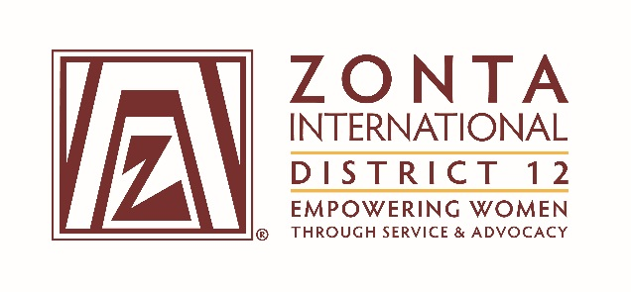

2016 Transitional Leadership Team Meeting
Holiday Inn Express Hotel
900 W. Yellowstone Highway
Douglas, WY
June 3 - 5, 2016

2014-2016 Board& Committee Chair Reports

Name: Deb Beatty

Position / Committee: Bylaws Chair/Parliamentarian

Goals:
  - Present proposed revisions to the District 12 Policies & Procedures Manual at the June 2015 District Board Meeting that includes the new ZI bylaws approved at the 2014 convention

  - Contact each club in District 12 by to determine if the club has bylaws and if they are up to date

Accomplishments

  - D12 Policies and procedures manual was updated and changes approved at the District Conference
  - Completely reformatted manual to streamline future changes
  - Contacted clubs regarding updated bylaws and assisted several clubs with changes.

What worked well?.
  - The P&P manual changes were not difficult. The reformat, while tedious, should really help for future changes to the manual.
  - It worked well to have 2-3 people to read the changes and also to delegate specific sections to people who are interested in that topic to write the changes and then add the language in to the document

What would you change?

  - Better communication from International.

