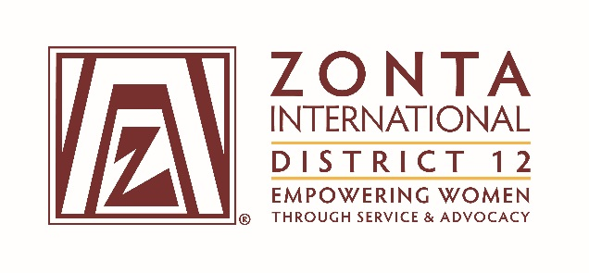

2016 Transitional Leadership Team Meeting
Holiday Inn Express Hotel
900 W. Yellowstone Highway
Douglas, WY
June 3 - 5, 2016

2014-2016 Board & Committee Chair Reports

Name: Sheila Davis

Position / Committee: Nominating Chair

Goal:
Recruit committed and skilled Zontians to serve on the District 12 and Zonta International Boards and Nominating Committees

Objectives:

- Identify potential candidates for each district position by February 28, 2015

- Ensure there is at least one candidate for the district nominating committee from each Area, and one additional candidate

- Complete a draft for all district positions by May 1, 2015

- Complete the final slate and ensure the nominations document that will be included in the 2015 Call to Conference is ready for printing per the District 12 guidelines by July 1, 2015

- Create a vetting process for nominations from the floor at district conferences by June 1, 2015

- Nominations for ZI Officers, Directors, and Nominating Committee members must be submitted directly to ZI by August 31, 2015

Accomplishments For the Full Biennium 2014 – 2016

- Identified potential candidates for each district position by February 28, 2015.
- Identified one candidate for the district nominating committee from each Area, and one additional
candidate from Area 3.
- A draft for all district positions was completed by May 1, 2015 and sent to the Governor.
- A vetting process for nominations from the floor at District Conferences was created by June 1, 2015,
was voted on at the 2015 District Conference, and was included in the 2015 update of the Policies and
Procedures Manual. A procedure for nominations from the floor for the 2015 District Conference was also developed and was included with the voting materials for the Conference.
- The final slate and nominations document was available for the 2015 Call to Conference by July 1,
2015. No candidate was identified for Area 2 Director, as the nominee (Linda Bogart) had been Area
Director previously. An amendment to the ZI Bylaws to allow an Area Director to serve again after three
bienniums was submitted to ZI for voting at the 2016 Convention in Nice. In April 2016, Kim Frazier,
Zonta Club of Laramie, agreed to be Area 2 Director, and Linda Bogart agreed to be D12 Secretary for
2016 - 2018.
- I submitted a nomination for Bridget Masters for ZI Treasurer and Secretary for 2016-2018 to ZI by
August 31, 2015.

What worked well? For the Full Biennium 2014 – 2016

- Creating a matrix for all potential candidates with yes/no/maybe results and a comments section proved
to be an excellent tool. Also listing possible future candidates for each position will help the next
Nominating committee.
- Sending job responsibility documents and a list of Leadership Team meetings to potential candidates to
help them understand the position.
- Having top-notch Nominating committee members to share the load!
- Developing the nominations from the floor process completed that action item from several bienniums
ago.

What would you change? For the Full Biennium 2014 – 2016

- Creating a list of past Area Directors and Vice Area Directors for D12 would be helpful and eliminate the
problem of asking someone who cannot serve again.
- Having so many women say no. Finding candidates seems to be getting worse (?). I asked 9 women to
be Area 2 Director.
- Developing a procedure and list of documents for the Nominating committee to use would be helpful,
as information is in many difference places.

