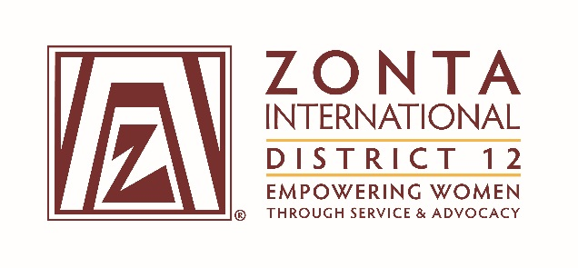

2016 Transitional Leadership Team Meeting
Holiday Inn Express Hotel
900 W. Yellowstone Highway
Douglas, WY
June 3 - 5, 2016

2014-2016 Board& Committee Chair Reports

Name: Marcy O’Toole

Position / Committee: Governor

Goals:
Leadership: Knowledgeable, inspirational leaders enhance the capacity of the organization to achieve its mission, and to motivate its members to participate at all levels.
- Perform duties as the Chief Executive Officer of the District & act as a liaison between the District and ZI
  - Schedule & hold board meetings, prepare agendas, & preside at all meetings
  - Prepare & hold a successful 2014 Governor's Seminar & 2015 District Conference
  - Visit or send a designee to visit every club in the District at least once in the biennium
  - Complete Governor's Reports to ZI by due dates
  - Revise the Policies & Procedures Manual as necessary & present for voting at 2015 District Conference

Accomplishments:(For the Full biennium (2014 –2016); be specific as this is intended to be final report AND assist the incoming person taking the position).

- Accomplishments:
  - Held seven (7) full leadership team meetings during the biennium (June, 2014; Sept 2014 (Gov. Seminar); January, 2015; June, 2015; Sept. 2015 (District Conference), and January 2016, and June, 2016.)
  - Held successful 2014 Governor’s Seminar (“Looking Inward/Looking Outward”) & 2015 District Conference (“HerStory of Heroes”)
  - Visited 15 clubs during biennium (included Area Meetings, officer installations, and other club visits).
  - Five (5) Governors reports completed and submitted to ZI. (Jan, 2015; May 2015; October 2015, January, 2016 and June 2016)
  - Policies and Procedures Manual updated and presented for voting at 2015 District Conference

What worked well?(For the Full biennium (2014 –2016); be specific as this is intended to be final report AND assist the incoming person taking the position).
- Excellent ZI liaison – Sharon Langenbeck who was very supportive and attended both A3/AE luncheons to present wings to the fellows. (on her own dime.)
- Good District team that worked well together. I know team members used the Emergenetics profile to assist them in communication styles.
  - Had a few resignations that had to be filled that interrupted continuity a little, but we were able to work through it.

What would you change?(For the Full biennium (2014 –2016); be specific as this is intended to be final report AND assist the incoming person taking the position).
- Develop biennial goals sooner with most work during the transition meeting and possibly during the Governor seminar meeting. 2014-2016 goals were finalized December, 2014.
- Appoint a “follow-up fiend” to have someone help follow-up on reports, items that are due, such as reports for leadership team meetings, outreach article submission.
- Appoint/designate a leadership development training leader to coordinate/track leadership training offered and completed during the biennium.

