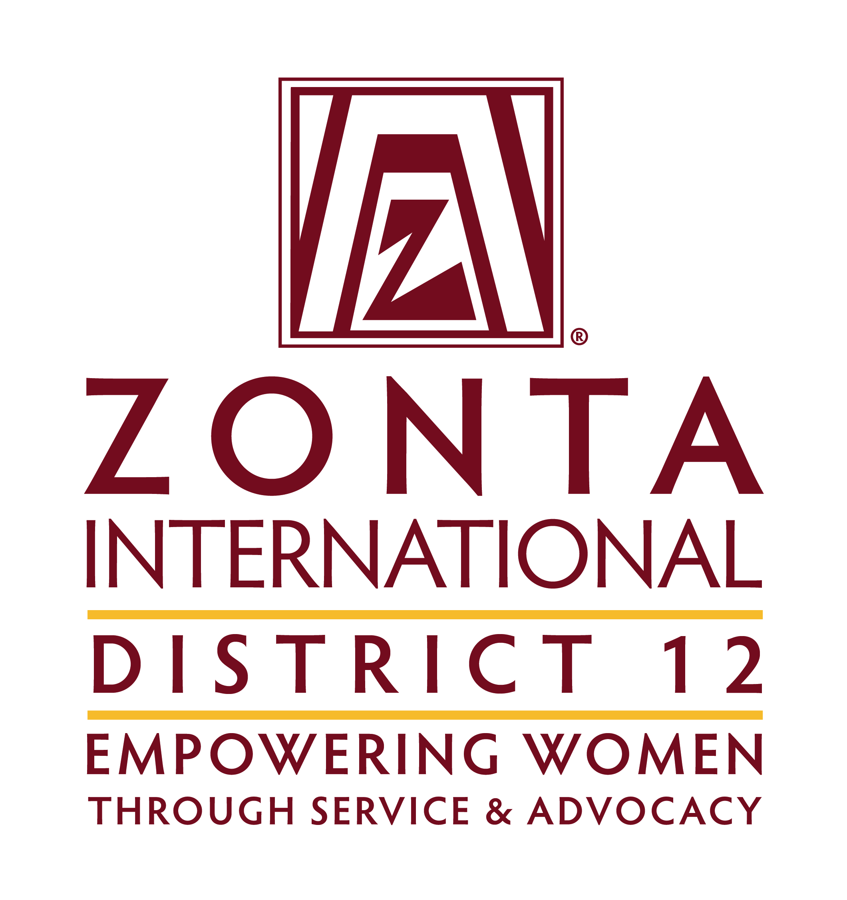

President’s Guide

May 2015

TABLE of CONTENTS

Introduction Page 3

Your Responsibilities Page 3

Tools and Resources Page 3

Club Board Page 4

Club Planning Page 5

Club Operations Page 5

Goals for Area Meeting Host Club Page 5

Insurance for Clubs Page 6

Use of Photographs and Videos Page 6

Sample Calendar Page 7

Attachment:

Photo and Video Release Form Page 12

Introduction
Congratulations, you have been elected as President of your Zonta Club. You play a crucial part in the success of your club. This guide will aid you by highlighting the resources available to you, explaining some basics and providing a list of activities in a calendar format.

Your Responsibilities

- Know and understand the Zonta International Mission, Objects and Structure (Club Manual).

- Understand and carry out all President responsibilities as outlined in the Club Manual.

- Establish Standing Committees – Appoint chairs and review their responsibilities (Club Manual).

- Review how to conduct a Zonta meeting prior to your first meeting (Club Manual).

- Establish a yearly calendar of meetings and events. Include dates and location of all regular business meetings, board meetings, special club events, retreats, District Conference in odd years, Governor’s Seminar in even years, and International Convention in even years. Also include deadlines for AE, YWPA, and JM Klausman awards. Be sure that every member has a copy of the calendar and that someone is responsible for keeping it up to date. Send a copy of the calendar to the Area Director.

- Communication between your Club, the District and International is vital. It is your responsibility to establish and improve this communication by sharing all mailings received with your club or the appropriate officer or committee. This information is contained in the Club Manual. Keep the Area Director and Governor aware of issues that may affect the wellbeing of the club. Share your successes.

Advice for Presidents

- Make use of all the wonderful resources available to you on the D12 and ZI websites. Do NOT re-invent the wheel.
- Put your Area Director’s contact information in your phone. She is your mentor and direct line to all the help, information, or concerns you might have.
- Encourage your committee chairs to keep contact info of their D12 counterpart handy as well.
- Delegate!

Tools and Resources

- Club Past President
- Area Director
- Area Presidents’ meetings or telephone conferences
- District Committees
- Many clubs pass a flash drive with information from president to president
- D12 website www.zontadistrict12.org
  - Leadership Training: President’s Responsibilities
  - Who We Are: Officers and Board Members, History, Clubs
  - Members Only Area: Strategic Plan & Biennial Goals, Annual Club Reports
  - What We Do: Advocacy, Scholarship & Awards, Service
  - Resources: D12 Outreach Newsletters, D12 Policy and Procedures Manual (Area Meeting host club responsibilities)
  - Home Page: D12 Map, D12 Calendar of Events - Area Directors can add events for clubs
- Zonta International website www.zonta.org
  - ZI Club Manual
  - Zonta International Governing Documents booklet (ZI Bylaws and Rules of Procedure; ZI Foundation Bylaws; and ZI Resolutions, Strategic Plan, and Biennial Goals)
  - ZI Marian de Forest Membership Manual
  - ZI Protocol Manual
  - ZI Foundation Manual
  - Z Club & Golden Z Manual
  - International Manual

Club Board

The president is the chief executive of the club. In conjunction with the club board, the club president reviews and aligns club goals and objectives with the long-term and biennium goals of Zonta International and the district. The goals must be discussed with, and approved by, the club members. The membership should be kept fully informed about all relevant Zonta business.

Major Club Board Responsibilities

  - Develop coordinated goals and monitor progress towards their achievement. Club goals must be aligned with long-term and biennial goals of Zonta International and District 12.
  - Recommend, but not determine, policy, advocacy actions, service projects and donations for adoption by the club.
  - Consider the budget(s) and present them to the membership for adoption.
  - Review financial reports, comparing actual versus budgeted income and expenses and ensure that proper financial controls are in place.
  - Receive reports of the committees and evaluate.
  - Ensure continuity of leadership and understanding of club board duties by meeting with the new, incoming club board prior to its assumption of office
  - Review and approve all individuals proposed for club membership.
  - Ensure that club bylaws are updated and aligned with ZI Bylaws and also fulfill the legal requirements in the country, province or state and local governmental unit where the club is constituted.

Note that on most issues the Board guides – club decides: e.g. budgets, service projects, advocacy actions, donations.

Effective boards:
- Effective boards are strategically competent. They keep a sharp eye on the future, identify trends in the environment, and formulate responses that position their club for future success.
- Boards need to support, encourage and inspire greatness in their organization if it is to survive and thrive.
- Ensure legal and ethical integrity and maintain accountability. The board is ultimately responsible for ensuring adherence to legal standards and ethical norms.

Club Planning

- Long Range Plan (Goals)
  - Create Planning Committee
  - Member Surveys/Interest Inventories
  - Use Healthy Club Inventory and/or Club Achievement Report as a guide
  - Could encompass multiple years (1 to 3 yrs.)
  - Include Succession Plan
- Mission Statement
  - Create and maintain a club mission statement that aligns with ZI and District 12
- Club Calendar
  - Use as a member communication tool
Club Operations

- Board Meetings and General Meetings
- Agenda for meetings
  - Remember your “PAL”
    - P: Purpose
    - A: Agenda
    - L: (Time) Limit
- Parliamentary Procedure – Robert’s Rules
- Club Annual Report
  - Reflect upon and showcase your club’s accomplishments
  - Delegate each portion to the appropriate board member or committee chair
  - The District Service Award and the District Advocacy Award are given based upon the information in the Local Service & Advocacy sections
  - Due to Governor in May
Goals of Area Meeting for Host Club

From the D12 Manual - Responsibilities of the Area Host Club:

The Host club shall:
- Arrange for:
  - A meeting place and necessary equipment.
  - Registration Table.
  - Refreshments during breaks.
  - A fundraiser to raise monies for the District Scholarship Fund. (See Section 7 E.)
- Prepare a budget in cooperation with the Area Director.
- Appoint committees and chairs, as necessary, to plan the Area Meeting.
- Submit a financial report to the Area Director.

Insurance for Clubs

Club events can be covered by the insurance Zonta International’s insurance policy. To obtain the insurance coverage for a specific event, contact ZI’s insurance agent, Cook & Kocher Insurance Agency, at (847) 692-9200. It is important to note that the ZI insurance does not cover the sale of alcohol. The policy does provide Host Liquor Liability, which only applies when the liquor is provided without any charge.

Clubs may also consider purchasing Directors and Officers Insurance. A club’s board of directors and officers could be personally named in a lawsuit filed against a club alleging fraud or financial mismanagement. Directors and Officer’s Insurance will cover the cost of defending the directors and officers and pay any resulting money damages.

Use of Photographs and Videos

If you are using a photograph or video of a person who is not a club member, you may need a written release or waiver from that person. Simply photographing a person in public view — including children and law enforcement officials — does not require a release or expressed consent. Generally, if you had the right to photograph a subject or scene, you also have the authority to display the photograph as an illustration of art or news – and that includes showing those images through social media, in print, or in news media. However, if you can clearly identify the person in the photograph (it is not a crowd scene) and you intend to use the photograph for “commercial purposes” or for the club’s benefit, a written release is necessary. In this context, commercial purposes are attempts to use the image in order to sell products or make money. This includes advertising or promoting goods and services. For example, if you have a photograph or a video of a person attending a Zonta function for which you charge a fee, you cannot use the image of that person to advertise the function for the next year. However, you could post the image on your Facebook page or use it in social media to show what the event was about. If the club is ever in doubt about whether or not the use is commercial, a release or waiver should be obtained prior to use of the photograph. A sample waiver is attached to this Guide.

MAY
PLANNING FOR THE CLUB YEAR

- Annual Club Reports due to ADs & Governor.
- Develop goals in conjunction with your Board and/or Committee Chairs. Keep in mind the current biennial goals and programs and Zonta’s Mission and Objects. Two sets of goals are needed- one should apply to this year/biennium and the second set for the club long-range plan. ( in Convention year probably should be delayed until goals are adopted)

- Share goals with the Board, Committee Chairs, and club membership. The club must vote to approve the goals.

- Complete committee selections.
  - Club president selects Committee Chairs, subject to approval of the Board of Directors.
  - Committee members are selected by the President.
  - Review leadership and service capabilities of members with outgoing President.
  - Each club member should be a member of a committee.
  - Assign new members to a committee as soon as possible.

- Plan an orientation for Board, Officers, and Chairs at or following the May board meeting.
  - Do officers have records and relevant materials from their predecessors?
  - Let chairs know when reports will be due.
  - Develop a time line for goals and reports.
  - Prepare a packet of information for each officer and chair, including a job description.

- Develop a list, including name, address, email and phone numbers, of Officers and Board.
  - Prepare a list of committees, with names, address, email and phone numbers of members.
  - Make available copies of International and club bylaws, club standing rules, and ZI Club Manual for Board members and Committee Chairs (these can be online).

- Prepare the club calendar for the year and have ready for the first meeting of the year.

- Ensure that the Club Treasurer has sent contributions to Zonta International Foundation (use the Foundation Transmittal Form – on-line).

9. ZONTA International and District Dues and club roster are due by or before JUNE 1.

10. Hold a joint Board meeting with new and old Boards to exchange records and relevant information.

11. Select Delegates to ZI Convention in even years.
12. Finalize plans to attend District Conference in September (odd years). Vote on delegates to District Conference. Send delegate information to the District Secretary.

13. Installation of new officers and board.

14. Have PR chair publicize club’s new leadership in the newspaper and on social media.

JUNE

- Confirm with the Treasurer that:
  - Dues and fees were sent to District and International along with the District and International Dues Transmittal Form and Membership Report Form.
  - If new officers have been installed, new signature forms have been signed at bank.

- Have Secretary send a list of Club Officer and Committee Chairs, including names, addresses, email addresses, and phone numbers to the Area Director and Governor.

- Update Membership Directory and send copy to Area Director and D12 Internal Communications Chair.
- Conduct June Board meeting –
  - Review your goals and plans.
  - Review and approve new committees and roles, ensuring all members are on a committee or have a responsibility.
  - Review club calendar so it can be distributed at the June meeting to all members.
  - Remind program and committee chairs of the following dates to facilitate planning of appropriate events, activities, or programs.

October 24 UN Day
November 8 Zonta’s Birthday
November 25 Day for Elimination of Violence against Women
November 25-December 10 16 Days of Activism
December 5 International Volunteer Day
January 11 Amelia Earhart Day
March 8 International Women’s Day/Zonta Rose Day
May 28 Women’s Health Day

- Finalize plans to attend the Zonta International Convention (even years). Remind convention delegates that a written report for presentation to the club is expected at the meeting following the International Convention.
- Finalize Jane M. Klausman Award and submit to Governor by July 1.

JULY

- Finalize plans for the club year keeping in mind that programs should emphasize service and express the International biennium theme and goals.

- Liaise with your membership chair regarding goals and plans for the year. Plans should include ongoing recruitment and orientation.

AUGUST

- Confirm with committee chairs that:
  - They have all the materials necessary for their respective committees.
  - They have conducted and/or scheduled a committee meeting.

- Review convention actions, using the Program Issue of the Zontian (even years) for report and/or appropriate action at the Sept. meeting.

- Encourage District Conference attendance in odd years and Governor’s Seminar even years.

SEPTEMBER

- Remind members of District Conference (odd years).

- Make plans for celebrating UN Day, October 24.

- If applicable, have treasurer file Form 990 by October 15 (for US Clubs).

- Initiate process for Young Women in Public Affairs and Jane M. Klausman awards; club winners are due to Governor by April 1st (YWPA) and May 31st (Klausman).

- Have delegates to Convention give report to club – even years.
- Plan to submit a Service or Violence Against Women project for the ZI Service Recognition Award. Check ZI website for due dates.

OCTOBER

- Confirm that treasurer has filed Form 990, if applicable.

- Observe UN Day October 24.

3. Finalize plans for Zonta’s Birthday, November 8.

NOVEMBER

- Celebrate Zonta’s Birthday, November 8.

- Zonta Says No and Sixteen Days of Activism Against Gender Based Violence November 25 through December 10 each year.
- In even-numbered years, send the names of Zontians recommended as candidates for Zonta International Office, Directorship and Nominating Committee membership to the District Nominating Committee.

DECEMBER

- Finalize plans for Amelia Earhart Day, January 11.
- Submit nominations to District Nominating Committees for district offices.

- Receive Emma L. Conlon Z Club Service Award Contest forms from headquarters and distribute to Z Club chair (if applicable).

JANUARY

- Observe Amelia Earhart Day, January 11.

- Elect Nominating Committee for the club if not done during regular elections.

- Plan activities to observe International Women’s Day, Zonta Rose Day, March 8.

- Begin plans for ZI International Convention (even years).

FEBRUARY

- Remind officers and committee chairmen that annual written reports are due at April or May meetings.

- Present proposed budget for coming year for approval at annual meeting.

- Confirm Club Treasurer has distributed dues notice to membership. Dues are due to club by:
(Zonta International Bylaws, Article XIV, Section 2b).

MARCH

- Elect delegates and alternates or proxies to the International Convention (even years). Register delegates and alternates on Clubs Credentials Registration Form or register online at www.zonta.org.

- Nominating committee report due.

- Begin District 12 Annual Club Report (this will be due to Area Director May 1- project to year end).

- In convention year, discuss with the club, issues, elections, etc. that will be covered.

6. International Women’s Day, Zonta Rose Day, March 8

7. Finalize Young Women in Public Affairs winner and submit to Governor by April 1.

APRIL

- Receive written reports from officers and committee chairmen.

- Conduct club annual business meeting (April or May).
  - Election of club officers, directors, and nominating committee.
  - Approval of budget for coming year.
  - Report of officers and committee chairmen (written report received earlier).
  - President’s annual report.
  - Recommendations for coming year.

- Submit District 12 Club Annual Report to Area Director by the date as specified by the AD.
( project info to the year-end)

- Submit International Officer Report Form – even if officers are the same – by May 1.
  - one copy to Headquarters
  - one each to Area Director and Governor.

- Conduct an annual audit for fiscal year ending May 31.

***** Reporting dates are sometimes adjusted by ZI, so please check with your Area Director for updates and details.

Attachment

PHOTOGRAPH AND VIDEO RELEASE FORM

I, the undersigned, hereby grant to the Zonta Club of __________________________ (“Club”) and its agents, the irrevocable, unrestricted right to use, publish, reproduce, display and distribute materials bearing my name, voice, likeness or any other identifiable representation of me or my family. These materials may appear in any form, style color or medium whatsoever (including, without limitation, photographs, video tapes, advertisements, films sound recordings, software, drawings, prints, broadcast, internet and electronic media.) I agree that all material containing any identifiable representation of me (including without limitation, all negatives, digital files, plates and masters of any photographs, files, prints or tapes) shall be and remain the sole and exclusive property of the Club.
I hereby waive any right I may have to inspect or approve the finished materials or any part or element thereof that incorporates my name, voice, likeness or any other identifiable representation of me or my family.
I hereby release and forever discharge the Club from any and all liability and damages relating to the use of my name, voice, likeness or any other identifiable representation of me or my family.
I have agreed to the above in consideration of the opportunity given to me by the Club to appear in these materials. I acknowledge that I have fully read and understand this document and that I have had any questions regarding its effect or the meaning of its terms answered to my satisfaction. I certify that I am at least 18 years of age, unless this document is also signed by my parent or legal guardian.

Printed Name Signature

Date:

If person is under eighteen years of age: I represent and warrant that I am the parent or guardian of the minor whose name appears above. I acknowledge that I have read the foregoing Agreement and am familiar with each and all of the terms contained therein, I am satisfied that the Agreement is fair and equitable, and I hereby give my express consent to its execution by my child/ward and will not revoke my consent at any time. I hereby release Club from any claims and causes of action I may have against them of any nature whatsoever.

Printed Name Signature

Date:

