Cheese and Wine Pairing Membership Event
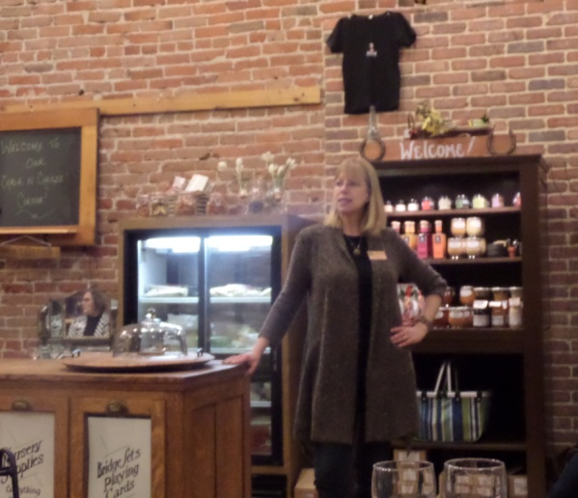
Wine and cheese go together very, very well -- just ask Zontian Cyndi Martin. Cyndi owns a downtown business called Chalk and Cheese, that sells a delicious variety of specialty cheeses from around the world, and on January 21, 2015 she gave Zontians and guests a lesson on pairing her cheeses with an amazing selection of French, Italian, Spanish and domestic wines. It was a sell-out event! Many guests attended and Tia Ocampo, our newest member joined that night! We now have 49 club members.

The Membership Committee looks forward to a busy Spring, with membership recognitions in March, induction of new members in April, and potentially several new members between now and the end of May! A potluck/Membership Social is tentatively planned for late June.

