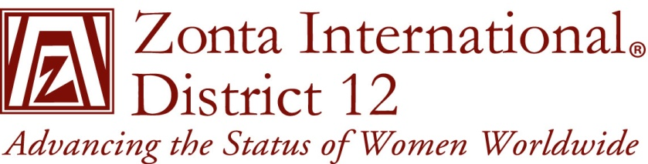
District 12 Rotation of District Conference & Governor’s Seminar

Year | Governor’s Seminar | District 12 Conference
2008 |  | Area 4 - Pikes Peak
2009 |  | Area 3 - Denver
2010 |  | Area 2 - Laramie
2011 |  | Area 1 – Black Hills
2012 | Area 3 – Denver II
2013 |  | Area 4 - Royal Gorge
2014 | Area 2 - Cheyenne
2015 |  | Area 3 - Foothills/Boulder Cty
2016 | Area 1 - Pierre Ft. Pierre or Sturgis
2017 |  | Area 2 - Converse Cty
2018 | Area 4 – Prowers County
2019 |  | Area 1 - Billings

Eligible host Clubs: (Based on size & reviewed annually)
Area 1 – Black Hills, Pierre Ft. Pierre, Billings, Spearfish, Sturgis
Area 2 – Laramie, Cheyenne, Converse Cty
Area 3 – Denver, Denver II, Foothills, Douglas County
Area 4 – Pikes Peak, Prowers County, Royal Gorge

