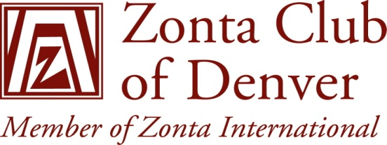

ZONTA CLUB OF DENVER

EMERITUS DUES STATEMENT

For the Fiscal Year June 1, 2011 to May 31, 2012

Due by May 1, 2011

Zonta International $83.00 *

District 12 Dues $32.00

Zonta Club of Denver Dues 0.00

Total Due $115.00

Make checks payable to: Zonta Club of Denver

Mail to: Nikki Headlee
35296 E. 10th Drive
Watkins, CO 80137-7197

Reminder: Dues paid after May 15, 2011, are subject to a $25 late charge. If paid
after June 1, 2011, a $40 reinstatement fee is added of which $15 is paid
to Zonta International.

In renewing your Zonta membership by the payment of your annual dues, you are also renewing your commitment to Service in the community here and abroad and the support of the club and your fellow Zontians.

- $3 is for club liability

