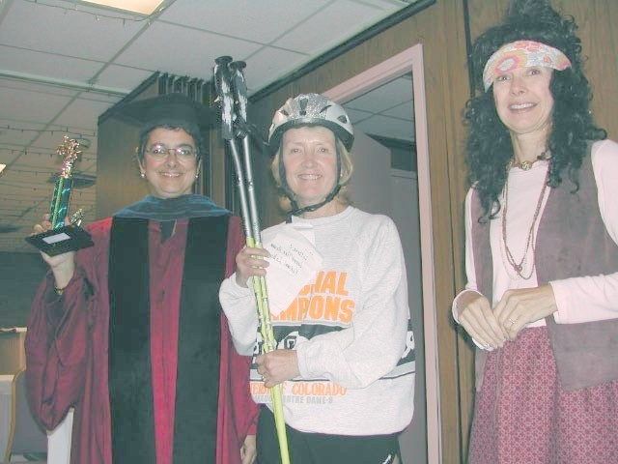
GovnrGram – September 2011
Greetings, Club Presidents & Board Members!

This message includes:
- Importance of Club Delegates at District Conference
- Proposed D12 Policies & Procedures 2011
- Gender & the Effects of Climate Change
- Addressing ...
- Instructions …
- 6th Feature Attraction @ 60th D12 Conference – Sunday Feature –Stylin’

Importance of Club Delegates

Electing your club delegate and supporting the voting process are two important ways in which we come together to be more than a local club. Clubs need to take the responsibility to learn how this decision-making process works. We now have conferences every other year, so significant matters that can’t be decided any other way are ‘saved up’ for action at a biennial conference.

This year we have over 8 voting items on the agenda. It will help us all greatly if you have questions regarding any of them to e-mail me so that we can address them most efficiently. The next two items (here below) are ones that will require your attention and understanding; please read carefully.

Proposed D12 Policies & Procedures 2011
Gender & the Effects of Climate Change

Dear District Governors,

On behalf of the ZI LAA Committee and ZI LAA co-chair Sigrid Duden, I am herewith sending you an important document created by Denise Conroy that should assist those clubs that are interested in studying and addressing Climate change and its impact on women in your local community and beyond.

This thoughtful document clearly relates the impact of climate change to Zonta’s Objects and to CEDAW articles, and links the impact of climate change on women/girls to persistent inequalities between men and women. We urge each of you to forward this email and the 2 documents that are attached to EVERY club in your District and to ask that each Club share the documents with its members.

There are numerous possible advocacy steps that clubs might take to address Climate change in their own district and nation. In particular, I urge you to ask that clubs give close attention to areas that Denise highlights should be beyond the action of a local club or particular District. The International LAA Committee will also be examining this document and discussing steps that might be taken globally. We urge clubs and districts that are interested in advocacy related to Climate Change and its impact to share their ideas/ strategies, etc. with your District LAA chair and/or with the ZI LAA co-chairs.

The second document I am sending is a list of on-line sources for more information about climate change that might guide club activities.
Additional information will be posted on the ZI website under LAA Tools – Climate Change as they are discovered. Districts are encouraged to link to the ZI Website to facilitate access by their members to additional information as it becomes available.

Thank you for disseminating this material to all of your clubs, and we look forward to receiving reports of LAA projects relating to Climate change and women.
We will be sending you additional suggestions for Advocacy steps that might emerge from country CEDAW reports.

Thank you for your help in sharing this important information with your clubs.

Sincerely,

Jean Bryant, ZI LAA Chair and Sigrid Duden, Vice Chair, ZI LAA Committee
jbryant@fsu.edu Sigrid.duden@gmx.de

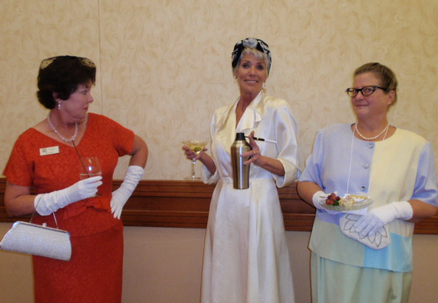

In the pictures above:
(left) At the September 2004 District Conference in Lamar, Laura McCutchen, Tommie Atanasoff, & ‘Loretta Lynn’ offered the ‘Beckon to Boulder’ for the 2005 Conference.
(right) In Laramie last year, Zontians Bev Ross, Arlene Ekland-Ernst and Cheryl McHugh demonstrated ‘Women of Style’ in the Nifty-Fifiies.

