**From:** Kay Meyer

**Sent:** Tuesday, October 04, 2011 12:34 PM

**Subject:** D12 GovnrGram - October 2011

**GovnrGram – September 2011**

Greetings, Club Presidents & Board Members!

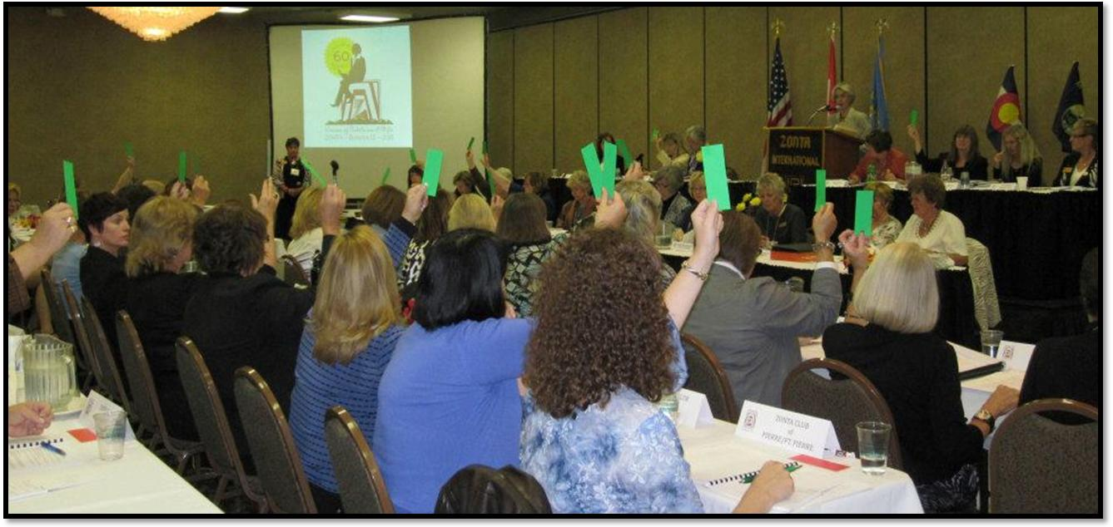This message includes:

* Summary of Motions Passed @ District 12 Conference 2011
* Directory Access @ D12 Website
* D12 Pin Design Contest
* Other Conference Follow-Up
* Calling all Greeley Contacts
* Club ‘Infotainment’?
* Exciting Plans Ahead

**Summary of Motions Passed at District 12 Conference 2011**

Executive Summary: The Delegates of the Conference passed all voting matters, and everyone on the Slate of Candidates for District Officer was elected.

The voting matters included—

* Treasurer’s Report & Compiled 2011 Financial Statements If questions, please contact Treasurer Bridget Masters or myself.
* Proposed 2012-2014 District Budget Our plan for use of District funds in the coming biennium, reflecting strategic planning priorities.
* Resolution to recommend Amendment of ZI Bylaws: adding YWPA Award Committee Being forwarded to the ZI Bylaws Committee.
* Resolution to recommend Amendment of ZI Bylaws: adding JMK Scholarship Committee Being forwarded to the ZI Bylaws Committee.
* Motion to adopt District 12 Platform for Advocacy Ensure that your club’s LAA committee has this help & guidance, including templates.
* Motion to adopt July 2011 Draft of D12 Policies & Procedures Encourage your Club members to become familiar with what it takes to make our District work!

These items will be posted on the District 12 Website. [The picture above shows D12 Delegates voting in the 9/24/11 business session.]

**Congratulations** to our new Officers-elect: Sheila Davis, Governor; Marcy O’Toole, Lt.Governor; Bridget Masters, (continuing) Treasurer; Reneé Coppock, Area 1 Director, Deedee Boysen, Area 2 Director; Debbie Squires, Area 3 Director; & Nancy Gerlock, Area 4 Director!

More congrats to our in-coming Vice Area Directors: Teresa Forbes, Area 1; Michelle Ammerman, Area 2; Laura McCutchen, Area 3; Linda Hawkins, Area 4!!

And yet more congrats to our incoming Nominating Committee: Chair Nikki Headlee; Sue Konstant, and Mary Walker!!!

This district is in good hands with leaders like these (I am *so* impressed); we must be doing *something good* .

**Directory Access @ D12 Website**

Lead a horse to water and she may drink… We are making a great deal of information more accessible to you & your club members on [www.zontadistrict12.org](http://www.zontadistrict12.org) .

Please check with your club delegate, who has a handout from the conference regarding 3 easy steps to access the up-to-date D12 Directory.

Club Presidents, **please ensure that copies of this handout are distributed** at your next Club Meeting.

(Security-conscious, we continue to avoid putting the password in any on-line communications.)

**D12 Pin Design Contest**

Presidents & Board Members, please share this with your Club members: Be immortal! Be world-famous! (Well, sort of…) Your design could go around the Zonta world!

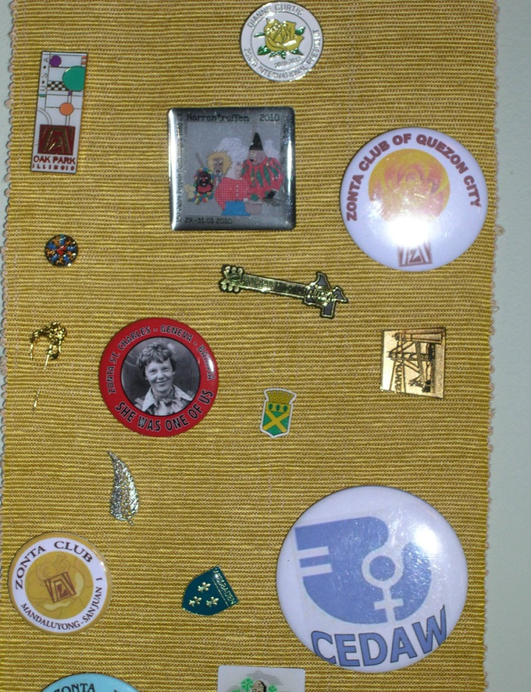Submit a design – to: [kay@meyergould.net](mailto:kay@meyergould.net) by April 21 -- with specifications as to material(s), size, & color. The design should exemplify our District or District 12 Zontians (on a good day…after coffee…). We’ve not yet developed further criteria for judging, nor named the esteemed panel of judges, so stay tuned for further developments. 50 pins will be awarded to the winning designer.

To the left you see a sample of some pins that I’ve collected at ZI Conventions. Many are metal covered with enamel. The gold, trapezoid one that is sideways (to the right of Amelia) is one of my favorites from District 9, the Golden Gate Area. Another is the square one in the center with fairy tale characters from a club in Germany, or the rectangular one from Oak Park, IL.

Then, there’s the brown, plastic potato from Idaho… (not shown here).

**Other Conference Follow-Up**

We are *still missing* our large state flags, flag holders, and several other items traditionally used at our District Conferences. Our normal procedures broke down in the transfer between the 2010 Laramie Conference and the just-completed 2011 Conference in Rapid City, and they were lost.

They **are** out there… most likely in some Zontian’s possession. We are not (yet) going to the significant expense of replacing them, but are still seeking your help to locate them. We are also now enforcing a procedure whereby any recipient of District property signs & dates having received such.

Please announce this at your club meetings, and *let me know* of any discoveries.

Handouts, pictures, & other items from the ten Speed-Learning Roundtables will be posted on the D12 website as we are able to gather and organize them. ZI Board Liaison Kathleen Douglass will also provide a summary of her insightful presentation.

If you have other specific requests, let me know.

It was a conference that accomplished a lot and left us all with a warm feeling that will linger for a long time.

We all owe a huge **THANK YOU** to our hosts, the Zonta Club of the Black Hills!

**Calling all Greeley Contacts**

At your club meetings, please ask all D12 Zontians to send referrals for prospective members they might know in Greeley, CO to Kathy Swafford, [k41swaf@aol.com](mailto:k41swaf@aol.com) , or Marcie Woolworth, [marcie@woolworthandcompany.com](mailto:marcie@woolworthandcompany.com). Ask everyone to please include their referral’s name & contact information. Our Area 2 SOM Team is building membership momentum and has scheduled the next Greeley meeting @ 5:30 PM on October 19th at the Centennial Park Library on 23rd Avenue in Greeley. Here’s where District-wide teamwork counts quite literally; please help out.

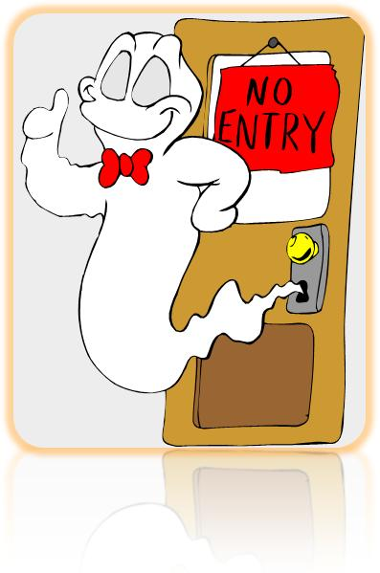**Club ‘Infotainment’ ?**

…Appearing @ Your Club meeting soon --*if you ask*.

These *used to* be called ‘club visitations’. That sounded something like ‘hauntings’, and neither Sheila nor I are that spooky.

Also, we D12 Board Members are so polite we don’t visit where we aren’t invited.

Our District procedures (Section 9.A.1) say, “*It is the responsibility of the club presidents to invite District Officers to attend their meetings.*” [See the rest of Section 9 for the other simple provisions. For example, your Gov should visit your club at least once per biennium.]

We District Board Members are a wonderful resource for your club. You can not only just give us a phone call for consultation on challenging issues, we are also eager to present best practices & up-to-date information to your club. And, there isn’t a dull, uninteresting, uninformed one among us! So, t’is the season (before *blizzards*) for visits & travel; invite us to visit your club!

**Exciting Plans Ahead**

Save-the dates:

* Area 4 -- March 24 in Lamar, CO
* Area 3 -- March 31 in Castle Rock, CO
* Area 2 -- April 14 in Ft. Collins, CO
* Area 1 – April 21 in Pierre, SD

Area Meeting content: There is so much going on & being developed in District 12 & Zonta International, it is hard to keep up with it all. The Area Meetings will offer an important opportunity to reconnect and catch-up on these developments, as well as offering interesting speakers & discussion. Don’t let your club get left in the dust!

The first District 12 Governor’s Seminar will be held on Sept 21-- Sept 23, 2012 in Denver. A featured speaker will be Mary Ellen Bittner, Zonta Past International President, 2004-2006. This will be an incredible opportunity that no Zontian should miss.

cid:image013.png@01CC8291.EC8BDE80

Since we are still launching this new Zonta year, I want to emphasize again the importance of communication and ensuring that your Club FEELS the strong network of colleagues in your District & Zonta International. WE ARE ALL ONE. We feel that strong bond during our conferences; it is full of vitality & strength.

**Help *keep* that fire alive this year!**

Your Gov, Kay Meyer

Here is a picture of some of the 2011 *Zontians of the Year* in District 12.

If you would like to see the image of their ‘alter-egos’, you will need to visit [www.zontadistrict12.org](http://www.zontadistrict12.org) .

