D12 GovnrGram – November 2011

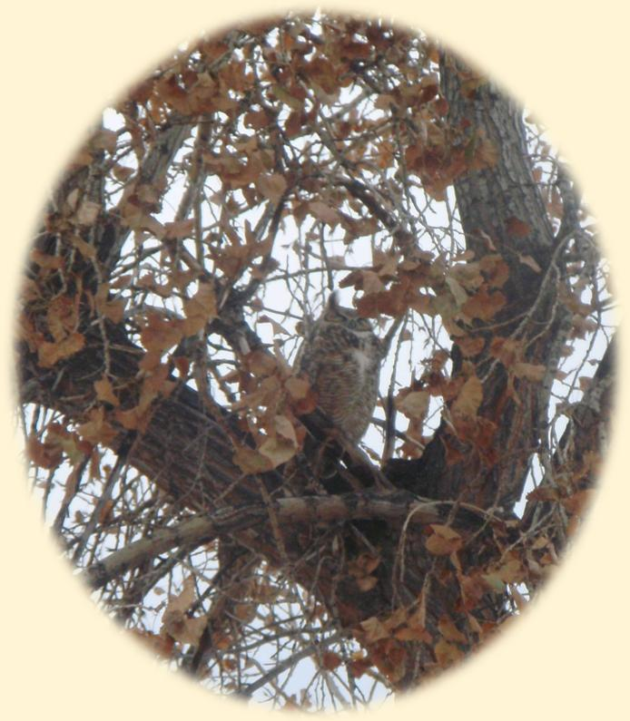
Greetings, Club Presidents & Board Members!
Look WHOOOO is standing guard right outside my window!
(I’ve been looking out at this magnificent Great Horned Owl
each morning for a week!)

This message includes:
- Zonta International LAA Newsletter
- Governor’s D12 2011 Conference Report
- Personalized D12 Website Tutorials
- Updated Club Manual: 2011 Edition now Online!
- Missing Conference Items
- D12 Image Design (incl. Pin Design Contest)
- Resource on Capacity–Building for Non-Profits
- Other Reminders for Follow-Up

Governor’s D12 2012 Conference Report Please let your club members know!

I think I speak for at least 90% of the Conference attendees when I say, “We had a blast! …Learned lots, too!” Attached is the report I submitted to ZI.
Delegates: I hope that you are giving a conference report (including resolutions & other voting items) to your club members! It is part of your responsibility as a delegate.

Zonta International LAA Newsletter Please let your club members know!

This very informative newsletter is posted on Zonta’s website: http://www.zonta.org/MemberResources/Tools/AdvocacyTools.aspx and for a while, it’s featured on the homepage under ‘What’s New.’ You can get a real sense of Zonta Legislative Awareness & Advocacy as you read the short articles submitted from around the world.* Plus, check out the left column for resources & info you can use in your own community!

(*Yes, District 12 did submit one article and it will be published in one of future quarterly LAA newsletters.) If you want to have your club’s advocacy featured, please contact D12 Advocacy Chair Sharon Roggy; she will be happy to assist!

Members-Only Web Access Training & Information Tours with Susie Nulty
Please let your club members know!

Three 20-minute tours for you to choose from! Each session will include how to access the D12 Website Members-Only area, the on-line directory, search tools, and navigation around the private & public web site areas, plus time for Q&A.
***Reservations are required*** Please send an e-mail to Susie Nulty and include your name, club, & session choice.

- Thursday, November 10, 2011 @ 10am
Conference call: 1-888-617-3400
Passcode 293623
https://www1.gotomeeting.com/join/138561896

- Sunday, November 13, 2011 @ 3pm
Conference call: 1-888-617-3400 Passcode 293623
https://www1.gotomeeting.com/join/193955024

- Friday, November 18, 2011 @ 4pm
Conference call: 1-888-617-3400 Passcode 293623
https://www1.gotomeeting.com/join/837092721
When starting the session (on one of the days & times listed below) put the link in your browser (Internet Explorer or Firefox), then call the toll-free number and follow the recorded instructions.

Updated Club Manual: 2011 Edition now Online! Please let your club board members know!

This is really required reading for every Club Officer (District Officers, too ☺). The new edition has been in the making for a long time.
Find it at http://www.zonta.org/MemberResources/Manuals.aspx , see ‘Club Manual’,
click on ‘open publication’ to easily peruse the manual, or you can download the .pdf file.

Missing Conference Items
Here are the D12 Conference items that have gone missing: (They are not small, inconspicuous objects…)
- Six large Flags —Zonta, United States, Colorado, Montana, So Dakota, Wyoming
- Six flag poles & heavy flag bases
- Traveling Hat (award)
- Traveling Bell (award)
- Large Wall Banner listing awardees (hand-quilted)
We are continuing the search for these items. If you have any new ideas as to their whereabouts, don’t hesitate to call either Sheila Davis or me.

D12 Image Design (including Pin Design Contest)

At the Board meeting following the District Conference, ZI Board Liaison Kathleen Douglass talked with us further about our District branding & image. Development of the D12 Image Design was assigned to a new ID Team: Janet Bergin (Chair), Diane Twining, Susie Nulty, Michelle Ammerman & Kristen O’Toole. This team will be developing some very basic parameters to guide D12’s (including clubs) global ‘look’. We will follow the ZI direction/guidelines and help in the development of club websites, business cards, and… a new D12 Pin.
Help us create buzz in Torino with our cool Pins!
Please let your club members know!
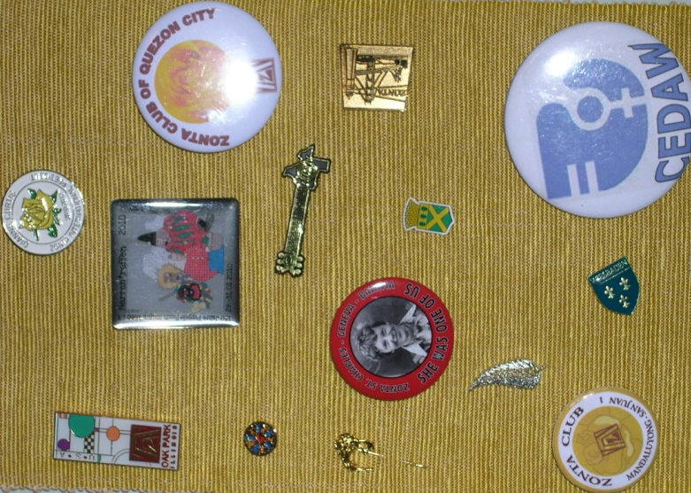
It’s fun! It’s easy! Here are the steps--
- Design a Pin
- Submit the design(s) to the D12 Design Jury*
- Win a Prize

The deadline is April 21 (the last 2012 Area Meeting)
The winning design will have ‘Zonta D12’ on it somewhere, be classy, capture the ID & ‘character’ of District 12, and be producible in a standard ~1” size.
The creator of the winning design will become rich & famous & be awarded 50 of the finished product.

* The D12 ID Team will be the jury. If you wish to send in your design now, please send it to me,
& I will forward it when the team gets organized.

Resource on Capacity–Building for Non-Profits

You might already be aware of the concepts & strategies of capacity-building. It seems to me that Zonta needs to apply such at all levels.
Here’s an excerpt from a recent McKinsey report:

All too many nonprofits, however, focus on creating new programs & keeping administrative costs low, instead of building the organizational capacity necessary to achieve their aspirations effectively & efficiently. This is not surprising, given that donors & funders have traditionally been more interested in supporting an exciting new idea than in building an organization that can effectively carry out that idea. This must change; both nonprofit managers & those that fund them must recognize that excellence in programmatic innovation & implementation are insufficient for nonprofits to achieve lasting results. Great programs need great organizations behind them.

Check out this site: http://www.vppartners.org/learning/mckinsey-vpp-ocat
The McKinsey report "Effective Capacity Building in Nonprofit Organizations," which includes the OCAT, is available for download completely free of charge.

Other REMINDERS for Follow-up
- Outreach articles – Due date for articles is November 10th! Send them to Anita Zastrow & Jody Gostas.
Each Area Director will soon be asking each Club President for an update on club activities. (This info will be used for the Outreach & for the December Report to ZI.)

- Share news of special events & fundraisers with other clubs in the district. Anita can send your ad to Area-wide, District, or customized e-mail lists. (We might like to come to those fund-raisers!)

- Membership –Please ensure your Club Treasurer is sending in the dues to D12 Treasurer Bridget Masters for those new members. Those inducted now can pay the half-year dues—what a deal! (You want them to be welcomed by this large, amazing organization, right? Well, we need their contact info.)
- Remember the dates – these are occasions for you to let your community know what Zonta does.
January 11 Amelia Earhart’s Birthday Celebrate in your club & community
March 8 Rose Day/Int’l Women’s Day PR emphasis Districtwide
- Start beating the drum about the 2012Area Meetings-- Please let your club members know!
March 24 Area 4 Meeting Lamar, CO
March 31 Area 3 Meeting Castle Rock, CO
April 14 Area 2 Meeting Ft. Collins, CO
April 21 Area 1 Meeting Pierre, SD

The 2011-12 Zonta Biennium will soon be 3/4 ^{ths} over! And, my guess is that you are about as goal-oriented as I am… So looking at that time frame—Eeeek! Gotta MOVE some things!
FYI: Former D12 GovnrGrams are now posted on the D12 website, if you might like to refer back to something. (For security purposes, personal e-mail addresses are deleted.)

Bravo for all your fine work! Keep the focus and please keep communicating!
Your Gov, Kay Meyer

PS: Just to brighten your day, here’s a link from Debbie Squires--Click here: Life of flowers

