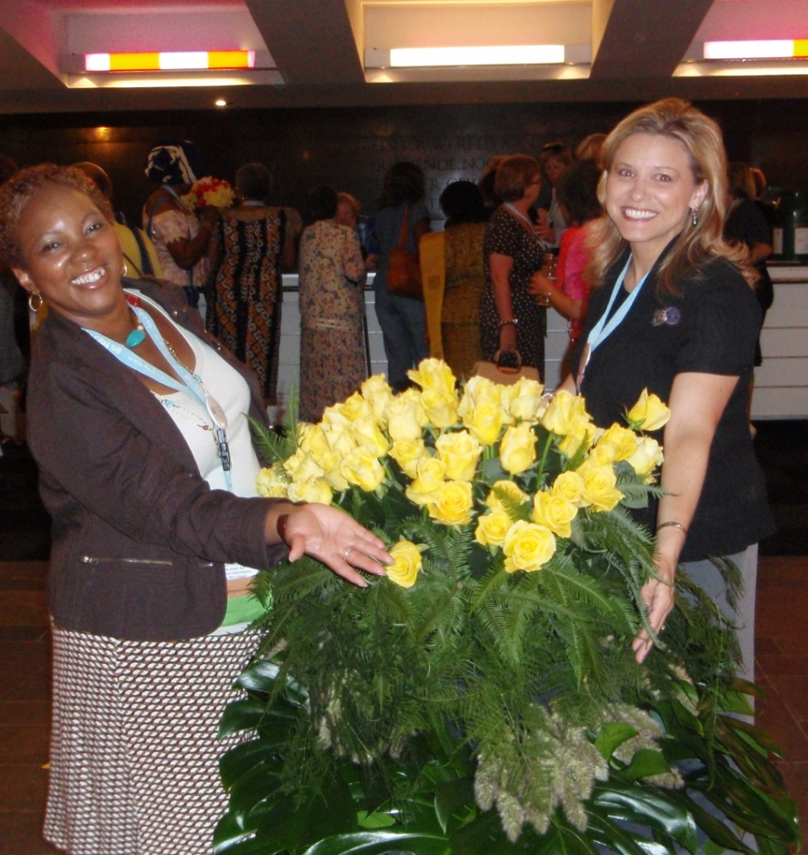

GovnrGram –March 2011

Greetings, Club Presidents & Board Members!

This message includes:

* UN Women Launch –youtube Link
* Voting results on D12 Govr’s Seminar Motion
* Club Member Retention & Leader Burnout
* Zonta International & Social Media
* Prep for D12 Area Meetings
* Planning ahead for 60th District Conference—Sept 23-25

*“…I encourage you as districts, clubs, and individual Zontians to celebrate International Women's Day and Zonta Rose Day in a meaningful way.   Plan a service project in your local community; invite a friend or colleague to learn more about Zonta membership; make a donation to the Zonta International Rose Fund.”   –Dianne Curtis, President, Zonta International*

*(excerpt from 3/1/11 email)*

UN Women Launch

--from MATarantula, ZI UN Chairman.  Go to [www.youtube.com](http://www.youtube.com/) and put ‘UN Women Launch’ in the browser.  (Oh, yeah, it *was* cool!)

**Voting results on Govr’s Seminar Motion**

--From District Secretary Carol Leffler--

Here are the results of the vote on the proposal and motion for a Governor’s Seminar.

We had 17 out of 21 clubs in D12 vote (81%), and 21 out of 25 delegates (84%) voted for the proposal and motion.

There were no votes objecting to the proposal.   So, it passed!

Just fyi, the following are the clubs that did not respond:  Spearfish, Gillette, Lakewood-Golden, & Royal Gorge.

**Club Member Retention & Leader Burnout**

Being a Zonta Leader is really hard. Zontians are smart, sensitive, critical, over-worked, & usually under-appreciated.

Being a successful leader in this ‘Org’ requires a mixture of courage, perseverance, knowledge, caring, enthusiasm, patience, organization, humility,

E-Q smarts, and diligent work. Let me mangle Frank Sinatra’s refrain… ‘If you can make it here, you can make it anywhere.’

(Hear that, Exec Search Recruiters!!)

So let me tell you how much I appreciate you District 12 Leaders who conscientiously dedicate your time & talents to making the world a better place though Zonta.  Don’t think your efforts aren’t noticed, because THEY ARE!  You make a difference for every one of us …& others you don’t even know. **THANK YOU!!**

For those club members who have been shouldering the load this year, show that you appreciate them.  How? A verbal announcement at the monthly biz meeting (e.g., “Let’s give Dorothea Lange a round of applause (& little gift?) for making that fund-raiser a success!”

OR/ Print some creative ‘*Certificate of Appreciation* to Roxy Ruckus’ in the Club newsletter.)

Maybe you haven’t seen much of some member(s)…  How about a little ‘Secret Leprechaun’ gift/card to a member who needs encouragement?  OR/ Send a ‘Hang in there’ email to someone with whom you have disagreed?  OR/get your Membership Committee to ask what members want next year.

Zonta International and Social Media

I don’t want to take up space here to repeat what’s on the ZI website, but it is important, especially the part with links to the official Zonta International sites, so please look up — [www.zonta.org/MediaNews/SocialMedia.aspx](http://www.zonta.org/MediaNews/SocialMedia.aspx)

Prep for D12 Area Meetings                                *Please follow-up on these items*

|  |  |
| --- | --- |
| Area Directors: | These are your meetings; please let us other District types know your theme, so we can plan to incorporate & echo it.  Idea: As a way to structure each Club Report, ask your Club Presidents to present their Club’s biggest achievements & biggest challenges (with time limit ☺).  Follow-up to ensure preparation & attendance from each club in your Area –See **** below. |
| D12BoardMembers: | You or one of your committee members should transmit the latest summarized info (no stale stuff) re your Subject Area to the Zontians at the meeting.  (See ‘Agenda Time Allotments’ + **\*** below.) |
| Club Presidents: | Ensure that at least 2 of your Club members attend the meeting—kidnap ‘em if necessary1.  Present your Club’s 2 biggest achievements and 2 biggest challenges thus far this year. (2 min)                                                                                                                                     (1…in this era of ill-humor, I’d like to clarify the humorous intent here.) |
| Host Committee/  Agenda Organizers: | **Budget**—Remember that this should be a ‘cost/revenue-neutral’ operation (i.e., income from the meeting registration fee should cover the total cost of the meeting.  Contact District Treasurer Bridget Masters ([blm3416@digis.net](mailto:blm3416@digis.net)) with questions.)  **Agenda Time Allotments**--Please allow 3-5 minutes each on the agenda for reports from the following  Lt.Gov/OMC; LAA; Service/Scholarships; and External/Internal Communications.  ZIF/UN needs 10 minutes.  Your Gov also needs 10 minutes (**\***her report will include messages from Zonta Int’l Board, the D12 Sec/Archivist, D12 Treasurer, and D12 Bylaws Chair &/or any Board Members who are not either represented or present).  This ‘District Download’ will total about 45-50 (packed) minutes, if one includes time for questions & transitions.  ****Let’s have a prizes for the clubs with the highest # of attendees &/or the highest %age of attendees. **** |
| Other Set-up: | * ZIF needs space for the big stand-up posters of International Service Projects. * OMC needs ½ of a table to sell conference bags and D12 brochures. |
|  |  |

Planning ahead for 60th District Conference—September 23-25

MC900363480[1]

Time flies… One of the interesting attributes of humans is our conception/perception of time, and our ability to act based on such.

Since we’re looking back in time during Women’s History Month & the Centenary of International Women’s Day, we also need to look *forward* to September…  Remember to act on Zonta-Rapid City-this-September as you look to the next 60—100 years!

                                                                       Best wishes & stop to smell the Roses!

                                                                       --Kay Meyer

Your District 12 Governor

*The photo above is from the ZI Convention in Rotterdam: Zontians Cheryl Lucas-DeBerry, Zonta Club of Milwaukee, and Vicky Bladl, Zonta Club of Janesville.