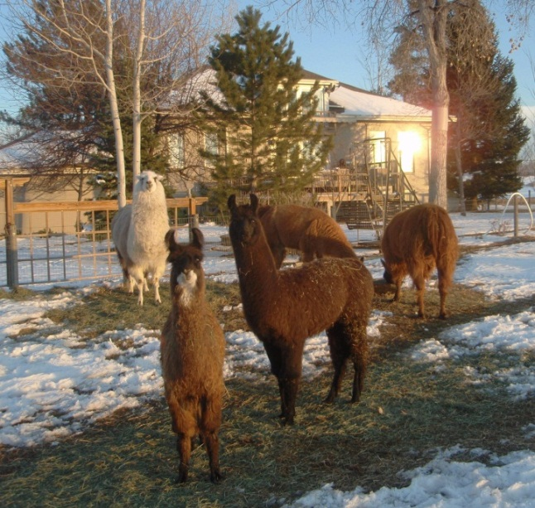
D12 GovnrGram –January 2012

Greetings, Club Presidents & Board Members!
 This picture is for our Board members who were at my house
in June when Sappho & Zeno (in foreground) were born.
Little Sappho’s first 3 months were very rough, but she’s
spunky & thriving now.

This message includes:

- National Slavery & Human Trafficking
Prevention Month, January 2012

- Governor’s Report to ZI--December 2011

- D12 Board Winter Board Conference Call

- Next deadline for the Outreach & Other
Reminders

National Slavery & Human Trafficking Prevention Month, January 1-February 1, 2012

Presidential Proclamation:

“Nearly a century and a half ago, President Abraham Lincoln issued the Emancipation Proclamation -- a document that reaffirmed the noble goals of equality and freedom for all that lie at the heart of what it means to live in America. In the years since, we have tirelessly pursued the realization and protection of these essential principles. Yet, despite our successes, thousands of individuals living in the United States and still more abroad suffer in silence under the intolerable yoke of modern slavery.
During National Slavery and Human Trafficking Prevention Month, we stand with all those who are held in compelled service; we recognize the people, organizations, and government entities that are working to combat human trafficking; and we recommit to bringing an end to this inexcusable human rights abuse…”
For the complete proclamation click here: Presidential Proclamation

Governor’s Report to ZI--December 2011

Attached is the most recent Gov’s Report. I took this occasion to include a summary of club Service projects that Arlene Ekland-Earnst is compiling to include on our District website. Please inform Arlene (eklandearnst@yahoo.com) if there are errors in this summary. This information was primarily gleaned from the Club Annual Reports of May 2011.

D12 Board Winter Board Conference Call

Coming right up… this Saturday, Jan. 7th @ 9 AM. The Tentative Agenda is attached.
This is the last time the Board will convene until June when us ‘old’ Board Members will be passing the torch to the new Directors.

Continued, next page…
Next deadline for the Outreach & Other Reminders

Please submit articles to Anita & Jody by February 4th. Our District Committee Chairs will ‘have the floor’ for updates on District Committee activities & issues. We also want to feature Club events for IWD/Rose Day, State Legislative happenings (related to our mission, of course), and plans for Area Meetings.

Please see the November GovnrGram for other timely reminders.
I also want to refer you to very good tool for Club Presidents: the Club Calendar, pages 57-60 in the ZI Club Manual http://issuu.com/zontainternational/docs/club_manual?mode=window&backgroundColor=%23222222

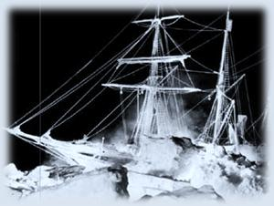
Perhaps the winter cold is getting to me… but a recent article caught my imagination…
An Antarctic explorer, Earnest Shackleton, faced harsh conditions in a way that speaks directly
to our time.
This 1914-1916 Endurance expedition is one of the world’s greatest survival stories and is taught as a case study in leadership training.
See-- http://www.pbs.org/wgbh/nova/shackleton/

The Shackleton expedition is a compelling story of leadership when disaster strikes again & again.
Novelist David Foster Wallace writes, “Real leaders are people who ‘help us overcome the limitations of our own individual laziness & selfishness & weakness & fear and get us to do better, harder things than we can get ourselves to do on our own.”

Here’s to learning how to be real leaders.
--Kay

