From: Kay Meyer
Sent: Tuesday, January 04, 2011 7:22 PM
Subject: ZONTA D12 GovnrGram -- January 2011
Attachments: D12Gvrnr's Report-ZI_ Dec 2010.doc; Zonta_AE_Invitation_1202.pdf

GovnrGram – January 2011 Greetings, Club Presidents & Board Members!
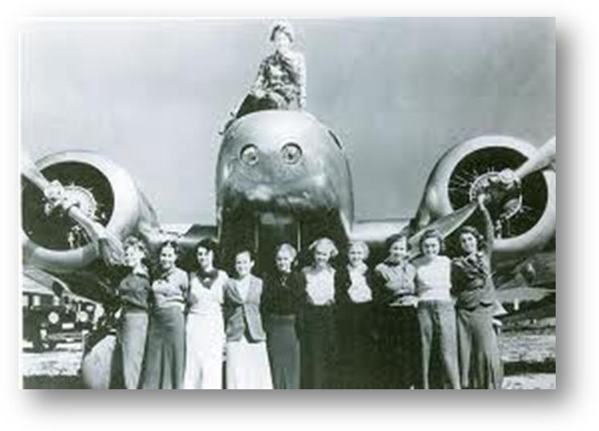
This message includes:
~ Kudos and Thank You’s
~ NewZ from ZI Board Liaison Kathleen
Douglass
~ Updated District Manual 2010
~ The Global Gender Gap Report 2010
~ Jan 8: D12 Board Conference Call
~ Jan 11 & 15: AE Day & Luncheon @ CU-
Boulder
~ Jan 16—Feb 5: K’s New Zealand Trip
~ Feb 4: Day at the CO Capitol
~ New Member Reminder

Kudos and Thank You’s

Kudos to Nikki Headlee & Sharon Roggy for frequently & clearly reminding us of that Bigger Picture: why we belong to Zonta—we find a place to help other women in our communities & states & make a difference in corners of the globe we may never personally visit. That Bigger Picture challenges us to go beyond our comfort zones… Meanwhile, we enjoy the company of other lively Zontians doing the same.

Kudos to Carol Leffler & Susie Nulty who are excellent Board Managers and keep all of us (especially me) in line.

Kudos to Sheila Davis for being everywhere at once--the best Lieutenant Governor a District could have.

Kudos to Mary Lou Edwards for the superb series of articles during the 16 Days of Activism! Each article had a section ‘What we can do’ that reminded us that Activism begins with each of us, and it’s not a ‘dirty’ word.
Mary Lou has just accepted Nikki’s and my request to be Co-Chair of the ZIF/UN Committee. She will focus on the UN portion while Nikki emphasizes the ZI Foundation side of things. There are 2 Chairmen (ZIF & UN) at the ZI level, and this will help the District 12 communication with ZI. We have combined the functions at the District level because our emphasis is on the ZIF-funded UN programs. However, ZI has new & better communication regarding UNWomen-related activities, so stay tuned…

Many Thanks to all the District Board Members who responded to my request for help on the December 2010 Governor’s Report. It is indeed an exercise in humility for a person to try to address the questions posed by the ZI form. I hope that I combined the responses in an adequate manner (see attached report).

The next report to ZI will be the Annual Reports, due from Clubs on May 1st, and from District Board Members on May 4th. Planning Reminder

NewZ from ZI Board Liaison Kathleen Douglass
Hard to keep up with this ZI Crew! Here’s the latest:
- On January 5th, The Zontian Magazine will be mailed—ensure your new members receive it (see ‘New Member Reminder’ below.)
- Next week ZI’s first e-Newsletter will be sent to all the members via email blast. This has been a dream of ZIP Dianne Curtis, who wants to make sure that we continue to bridge the gap between Zonta International and all members. There will be an e-Newsletter every month. (See ‘GovnrGram’ comment at end.)
Through the e-Newsletter, ZI Staff will make it very easy for Zontians to link to the tools & information on the ZI website. And, with this first e-Newsletter, Zontians will also be able to link live to ZI social media pages. If you are inclined to participate in social media, think about opening your accounts.
- The MOUs (i.e., contracts) with our ZIF partners have been signed - an announcement of the completed MOUs will be in the e-Newsletter.
Updated District Manual, December 2010
Wow, it’s done! There on the ZI website www.zonta.org/member_resources/manuals This is probably not due quite so much enthusiasm from you Club Presidents, but we on the District Board use this A LOT. The ZI Bylaws Committee managed to shrink the number of pages (from 111 to 91) while increasing the font size… Hurray! There are numerous changes of which the Board will need to be aware & discuss. Our District 12 Bylaws Committee will have a big job ahead of it to help us update our District 12 policies.

The Global Gender Gap Report 2010
Sigrid Duden sent me this link: It is a new report from the World Economic Forum--an independent, international organization of business, political, academic & other leaders, based in Switzerland.
The Global Gender Gap Index was created with the specific purpose of being comparable across time. The 2010 Report aggregates five years of data and seeks to reveal country progress in a transparent manner. See http://www.weforum.org/s?s=The+Global+Gender+Gap+Report This is a very data-driven economic report that does not consider the level of development nor size of the countries’ economies but only the difference in the levels of outcomes by men vs. women.
A snapshot of some overall rankings that I think you will find surprising:
For economic equality, Iceland ranks #1; New Zealand-#5; Spain-# 11; USA-# 19; Austria-#37; France-#46; China-#61; Romania-#67.

January 8: D12 Board Conference Call
Board Members: You should have received ‘Call-in Instructions’ from Susie Nulty, and Denver logistical instructions from Carol Leffler. Everyone, please call me* if you have any questions or comments for the Board. (*KLM 303-665-5273)

January 11 & 15: AE Day & Luncheon @ CU-Boulder
Most Clubs in District 12 celebrate Amelia Earhart’s birthday somewhere around Jan 11. This year, our district is honored to host ZI Amelia Earhart Committee Chair Sharon Langenbeck, who will present the AE pins & certificates to 7 AE Fellows at a fund-raising luncheon January 15. This luncheon is being co-hosted by the CU Department of Aerospace Engineering. You are all invited to attend (see attached invitation). We are indeed proud to carry-on Amelia’s support of women in flight and in challenging careers.

Jan 16—Feb 5: K’s New Zealand Trip Please hold e-mails & calls 1/16-2/5
Visiting Kiwi country is a 50-year dream-come-true for me. My friend Sigrid (Heidelberg Zontian) & I will be visiting numerous Zontians we know there (and a few we don’t know) while seeing the sites of both islands. So, this is my OUT-OF-THE OFFICE message. The February GovnrGram will be sent out late. If any of you want to hear about Zonta in New Zealand, I’ll be happy to share what I learn.

Feb 4: Day at the CO Capitol
This is a very special opportunity to get an up close & personal look at how & where Colorado laws are made. We hope that this kind of visit can happen in every state. You can learn more from D12 LAA Committee Member Alice Borodkin.

New Member Reminder Send reminder to your club Treasurer!
I hear rumors that there are lots of new members, but they aren’t showing up on our District or ZI rolls. Please ensure that your Treasurer has sent those New Member Dues to District Treasurer Bridget Masters. (Bridget sends the info & $$ in to ZI, forwards member info to Anita Zastrow & Sheila Davis for District records and to send a District welcome back to each new member.)

Last month I asked for feedback regarding this G’Gram. About 10 of you were kind enough to respond, and you were very encouraging—THANK YOU! Once the new ZI e-Newsletter is launched (see above), we can reassess whether there is a need to continue this. I’ll rely on your feedback… Remember that half of ‘bridging the gap’ is from your end of the ravine.

Best regards & Happy New Year!
--Kay Meyer
Your District 12 Governor

PS: The intro picture was pulled from Amelia Earhart archives. The only information I found on it was that it was taken just before her last flight.

