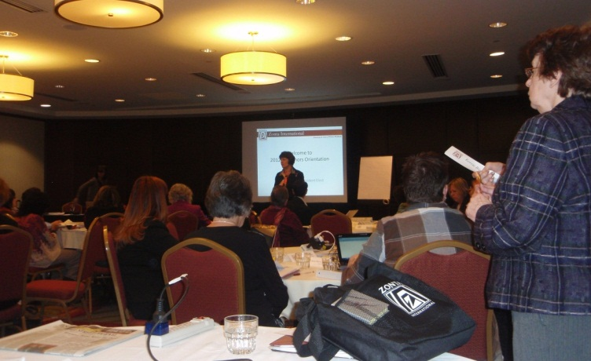
D12 GovnrGram – February 2012

Greetings, Club Presidents & Board Members!

 Sheila & I just returned from Incoming Governors’ Training @ Zonta Headquarters in Chicago.

This message includes:

- Congratulations from ZI Board Liaison Kathleen Douglass
- New ZI LAA Newsletter

- Last Minute Outreach Deadline

- Young Women in Public Affairs Award Reminders

- Another ‘Nag’ re New Members

- Area Meeting Dates

- UN Women’s 16-Step Policy Agenda

- Use of Club Achievement Checklist

Congratulations from ZI Board Liaison Kathleen Douglass

Arriving today from Kathleen—

Good morning Madame Governor:
I would like to congratulate District 12 on the excellence your district has displayed in regards to support of the Zonta International Foundation.
D12 is again in the top 5 donors for the Amelia Earhart scholarship fund and the top 6 in both JMK & ZISVAW programs. What thrills me so much is that 100% of your clubs have made a donation to the Foundation and individual donors have increased from 5% in the previous biennium to 14%, which is quite a big jump. I believe this indicates strong leadership by the district board, solid education from your ambassadors & committee chairs and a true commitment from Zontians in D12. Please pass on my comments to your board members & club members as appropriate. The donation year is not over yet - Zontians have until April 30 to have their donations recognized at convention!

Thanks so much for your continuing support.
- Regards, Kathleen Douglass
ZI/ZIF Director, 2010-2012
Addendum from your Gov…
A big thank you goes out to Nikki Headlee, D12 ZIF Ambassador, whose idea of ‘Dining-In’ events has been so successful where it has been implemented.

And, a second thank you to the Clubs (Billings, Cheyenne, Converse County, Denver, Denver II, Douglas County, Ft. Collins, Pikes Peak, Prowers County) who have hosted ’Dining-In’! The 14% mentioned by Kathleen means that ~78 Zontians in District 12 have contributed individually, and ~480 have not.
(However, we think that not all the individual contributions are included yet on ZI’s total. ☺)

I hope that other D12 clubs are planning to ‘Dine-In,’ & that additional Zontians are willing to put their $$ toward our very important Zonta International Service & Scholarship Projects. Club Presidents, please mention Kathleen’s comments & this April 30 deadline to your members; let’s ‘knock their socks off’ in Torino!

New ZI LAA February Newsletter
Hot off the press! Soon to appear on the ZI website, but you get an advance copy – here attached! The LAA Newsletter features a content theme with each edition. I think you will find the advocacy perspectives in this edition quite thought-provoking. (And, check out those Zontians from Cheyenne.)

Last-minute Outreach Deadline

Well, Anita & Jody humored me by extending the deadline for articles, but it won’t stretch it past this weekend. Our District Committee Chairs will ‘have the floor’ for updates on District Committee activities & issues. We also want to feature Club events for IWD/Rose Day, and plans for Area Meetings. Ensure your news is included!

Young Women in Public Affairs Award Reminders

We hope that your club has already sent the ZI YWPA promo material to your local high schools. (There is a great poster on the ZI Website that you can print out.)
Please ask applicants to –
- adhere strictly to the word count,
- answer both parts of Q4 & ask for meaning clarification, if necessary, and
- provide only 2 signed, succinct recommendations.

Ensure that your club selection committee adheres carefully to the ZI YWPA specifications for selection. After your club’s selection, send the winner’s scanned PDF files (application materials with those important signatures) by April 1 to District 12 YWPA Award Coordinator Janet Bergin.
The District 12 winner will be informed by May 1, and her application forwarded to Zonta International. Contact Janet if you have further questions.
District 12 awards one YWPA Award recipient from the district $1,500 each year ($1K from ZI funds & $500 from District) & and submits the District winner to the Zonta International Selection Committee. ZI selects five winners for international awards of $3,000 each.

Another Nag re New Members

Actually we’re doing a little better here, but March 1st represents another Census Date in Zontaland. Whatever your club membership total is on March 1 determines the number of delegates you can send to Convention. Once again, please ensure your Club Treasurer is sending in all dues to D12 Treasurer Bridget Masters so that your club is in good standing for all voting purposes. And remember, a member’s official date for joining Zonta isn’t when you inducted her/him; it’s when ZI receives the paperwork.

Area Meeting Dates

The 2012 Area Meetings are coming right up! Please let your club members know!
March 24 Area 4 Meeting Lamar, CO
March 31 Area 3 Meeting Castle Rock, CO
April 14 Area 2 Meeting Ft. Collins, CO
April 21 Area 1 Meeting Pierre, SD
The Outreach will have further information on each of these meetings.
Our Host Clubs & Area Directors are putting together informative, inspiring meetings your Club members won’t want to miss. Get up-to-date on what’s happening!

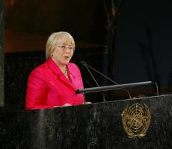
UNWomen’s 16-Steps Policy Agenda

On 16 November 2011, UNWomen Executive Director Michelle Bachelet outlined a comprehensive policy agenda to end violence against women globally.

Focusing on the three critical pillars of prevention, protection and provision of services, Ms. Bachelet’s call for action urges world leaders to mobilize political will & investment to ensure that women can live a life without violence. See http://saynotoviolence.org/around-world/news/un-women-announces-16-steps-policy-agenda

The theme for International Women’s Day 2012: Connecting Girls, Inspiring Futures
New York and Worldwide, 8 March 2012
http://www.internationalwomensday.com/contact.asp

Use of Club Achievement Checklist

Featured in ZI’s February E-newsletter was information regarding the Club Achievement Checklist. This tool is similar to our Healthy Club Inventory, but it’s shorter & only allows yes/no answers. There are 50 questions distributed into eight categories. Those clubs who do choose to participate & answer yes to the minimum number of questions required will be recognized at the 2012 Convention in Torino. Forms can be completed online or can be downloaded and returned to Margaret Ingram. The deadline for submission is 1 May 2012. Our District has some outstanding Clubs that can shine; check it out!

~~Lastly, a ‘Valentine reminder’ from Oscar Hammerstein

- A bell’s not a bell ‘til you ring it.
- A song’s not a song ‘til you sing it.
- Love in your heart wasn’t put there to stay.
- Love isn’t love ‘til you give it away.

Dear Zontians, thank you for the love you give away every day.
Zonta hugs, Your Gov--Kay

