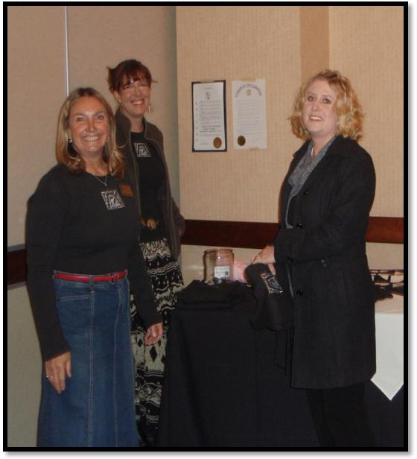
GovnrGram – April 2011

Greetings, Club Presidents & Board Members!

This message includes:

- District in Receipt of YWPA Applications
- Area 2 Meeting & other D12 Area Meetings
- NomCom Reminder & Clarification
- Club Annual Reports—Due May 1
- Tell Your R&R Success Stories
- First Feature Attraction @ 60th D12Conference

District in Receipt of YWPA Applications

Eight clubs-- Royal Gorge, Pikes Peak, Prowers County, Cheyenne, Black Hills, Spearfish, Pierre, and Billings*--have submitted their YWPA Club Winner applications to District YWPA Award Coordinator Janet Bergin for District review.
The District 12 YWPA Winner will be announced in early May, and that application will be forwarded to Zonta International to be evaluated for one of the five International YWPA awards. We will also work out the details of the presentation of the District award ($1,500) and inform you regarding this at a later date. *Most communities announce or publish their scholarship winners around the time of commencement. You may wish to ensure that your Club’s winner receives this recognition.

Note: Time to think about recruiting candidates for the JM Klausman Scholarships. Applications will be due to District Chair Susan Miller Sutphin July 1st.
(See attached brief summary regarding ZI Scholarships & Fellowships.)

Area 2 Meeting & other D12 Area Meetings

 We learned a lot at the Area 2 Meeting that might be applicable at our other 3 Area Meetings.

Area Directors: | Contact Club Presidents to ensure preparation & attendance from each club in your Area –See  below.  (Mary arranged for ‘clubs’ greatest successes & greatest challenges part’ to be a panel (rep from each club), and it created a lively, valuable dialogue.) Please allow time for such a discussion if you can.
Follow-up—
- Send the Final Accounting of the Meeting to District Treasurer Bridget Masters (blm3416@digis.net) by May 5th.
- Submit a short (no more than half-page), snappy article summarizing your meeting to Anita Zastrow (anitazastrow@pie.midco.net) by May 10th for publication in the May Outreach. Pics are great.

D12BoardMembers: | You or one of your committee members should transmit the latest summarized info (no stale stuff) re your Subject Area to the Zontians at the meeting. (At the A2 Meeting, this was great because we have impressive Board Members, and these presentations enable more than just an exchange of info.)
Club Presidents: | Ensure that at least two of your Club members attend the meeting. (One member attending is really not adequate because there is just too much that goes on for one person to take back to the club.)
Agenda Time Allotments: | Please allow 3-5 minutes each on the agenda for District Officer & Committee Reports. Your Gov needs at least 10 minutes. Her report will include messages from Zonta Int’l Board & Board Members who are not either represented or present. (45-50 (packed) minutes for this ‘District Download’ seemed to be a good time estimate.)
Other Set-up: | - ZIF needs space for the big stand-up posters of International Service Projects.  - OMC needs ½ of a table to sell conference bags and D12 brochures.

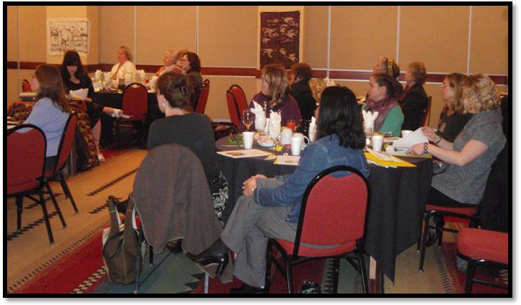
NomCom Reminder & Clarification

The District 12 Nominating Committee soon will be sending out a second reminder regarding the nominations for District elected officers. The deadline (April 23) for the receipt of nominations is fast approaching. This District is fortunate a great Board, and this happens because the Nominating Committee works hard and because you nominate good leaders. Several nominations for the same position is OK; in fact, it’s exciting.
If you know someone who would help to move this district ahead, get her OK, then put her name forward. Please contact one of the members of the Nominating Committee -- Priscilla Romkema (romkema@rushmore.com ), Kathy Dean (KDean@bakerlaw.com), or Pat Kiovsky (patkiovsky@aol.com) -- if you have questions.

Club Annual Reports 

Club Presidents: Your Annual Report should be sent to me and your Area Director by May 1st. (Form attached.) Smart Presidents send out sections of the club report to the various committee chairs about now…

Also, like last year, local service funds awarded from all D12 clubs will be totaled so that we can continue use those to use those figures for informing our communities about the difference Zonta makes. (Look at the current D12 Membership Brochure. The club annual reports were the sources for the projects listed & the $200K noted there.) I’ll even ‘spiff-up’ the June¶ GovnrGram to be a kind of D12 Annual Report so that you receive the summarized info ASAP, & we have it in one place for multiple uses. Remember also that the District uses the information in these reports as the initial entry for selecting the District Service Award.

Presidents: please don’t delay sending in your report; if I don’t have it by the Governor’s report deadline (May 9), I won’t be able to include your club’s information in what I send to ZI. However, I will be just as persistent in obtaining all the reports as I was last year ☺. Please don’t make me nag!
Board Members: I will ask for your help on any section(s) of the Governor’s report that relate to your area of expertise, as I did before.

Tell Your R&R Success Stories

In the next (June) issue of The Zontian magazine recruitment & retention success stories will be featured. Numerous clubs in our District have creative strategies & solid success stories. If your club has been successful in recruiting and retaining members, please share your successful strategies with other Zonta Clubs who might be struggling. Your stories should be submitted to pr@zonta.org or via the Share Your Story feature on www.zonta.org by April 30th. Photos are encouraged.
‘Want to see some previous success stories on the website? Go to http://www.zonta.org/WhatWeDo/ClubSuccessStories.aspx

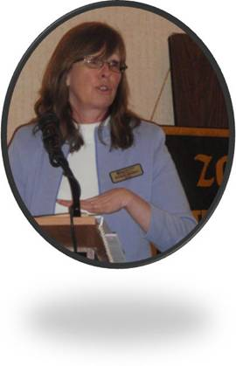
First Feature Attraction @ 60th D12Conference —Sept 23-25

The Rapid City Club’s 2011 Conference Committee, chaired by Jan Kirch and Kyle Blada, is putting together a wonderful combination of events and content that you won’t want to miss. The Kick-off Event will be a Welcome Reception & program at (what I think may be my favorite store) The Prairie Edge (www.prairieedge.com ) on Friday evening. To those of you who haven’t visited TPE: you are in for quite a surprise. For those of you who have been there: I know you will appreciate how very special it is for them to invite us there for a private event.
Each month I’ll send you another Feature Attraction for our 60th Conference…

Quote for today: I'm less interested in why we're here. I'm wholly devoted to while we're here. ~Erika Harris, lifeblazing.com
--Kay Meyer
Your District 12 Governor

The photos above are from the Area 2 Meeting in Cheyenne. Top: Cool Laramie Zontians. Middle: Zontians enjoy hearing Denise Parrish’s presentation on infrastructure in developing nations. Bottom: Bridget makes ‘Dues’ interesting.

