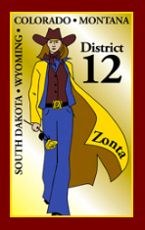
Registration Form
Zonta District 12
2014
Governor’s Seminar

Looking Inward
Looking Outward

Laramie County Library
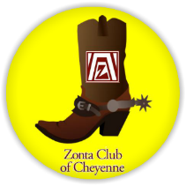
Cheyenne, WY
September 20th, 2014
Hosted by:
Attendee Information
 | PLEASE ENTER INFORMATION HERE
First Name:
Last Name:
Home Street Address:
City:
State:
Zip:
Home Phone:
Cell Phone:
Email Address:
Date of Arrival:
Lodging Accommodations:
District Board Member: | Yes ☐ No ☐
*Registration Must Be Completed and Payment Received No Later Than: September 1st, 2014
The Emergenetics Profile must be completed prior to the actual seminar. For this reason, no late registrations can be accepted.

Event Selection - Please Check All That Apply
Option | Governor’s Seminar Activity | Cost | Check to Participate in this Activity
1 | District Board Meeting (District Board Only By Invitation) - Friday, September 19th, 2014 - 2:30 pm to 4:30 pm - 1401 Airport Parkway, Ste. 300 (Align Business Office) | No Charge | ☐
2 | Friday Evening Mixer (Optional) - Friday, September 19th, 2014 - 6:00 pm Cocktail Hour - 7:00 pm Hors D’oeuvres and Wine Glass Painting - Suite 1901 Martini Bar and Restaurant - 1901 Central Avenue | $20 | ☐
3 | Governor’s Seminar - DO NOT SELECT THIS OPTION IF YOU HAVE ALREADY COMPLETED THE EMERGENTICS PROFILE – SEE OPTION 4  Saturday, September 20th, 2014 - Registration: 8:30 am - Seminar: 9:00 am | $70 | ☐
4 | Governor’s Seminar – Previously Completed Emergenetics Profile – This generally applies to District 12 Board Members – DO NOT SELECT THIS OPTION IF YOU HAVE SELECTED OPTION 3 ABOVE - Saturday, September 20th, 2014 - Registration: 8:30 am - Seminar: 9:00 am | $50 | ☐
5 | Saturday Evening Event (Optional) - Old West Museum - 4610 Carey Avenue - Cheyenne Trolley Tour Ride - 6:00 pm Arrive at Museum - 6:15 pm Trolley Tour - 7:30 pm Dinner at Old West Museum | $35 | ☐
Total Cost for all Events if you have not already completed the Emergenetics Profile $125 | Total Cost for all Events if you HAVE already completed the Emergenetics Profile $105
Total
Please send checks payable to Zonta Club of Cheyenne to Mary Walker, P.O. Box 20025, Cheyenne, WY 82003. If you would like to pay via credit card or have registration questions, contact Mary at mkw1901@aol.com. Credit Cards can be accepted and will be processed by club member Renee Conner. Her email address is renee.conner@crmcwy.org.

For Discounted Hotel Price please reserve your rooms by August 19th, 2014 - Refer to Zonta of Cheyenne • Towne Place Marriott $109 nightly (307) 634-0400
• Holiday Inn Express $119 nightly (307) 433-0751
Align Office  Address: 1401 Airport Ct, Cheyenne, WY 82001  Phone:(800) 999-6541 | ALIGN 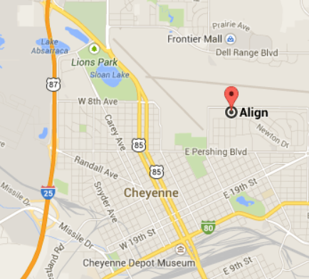
Suite 1901  Address: 1901 Central Ave, Cheyenne, WY 82001  Phone:(307) 634-1901 | SUITE 1901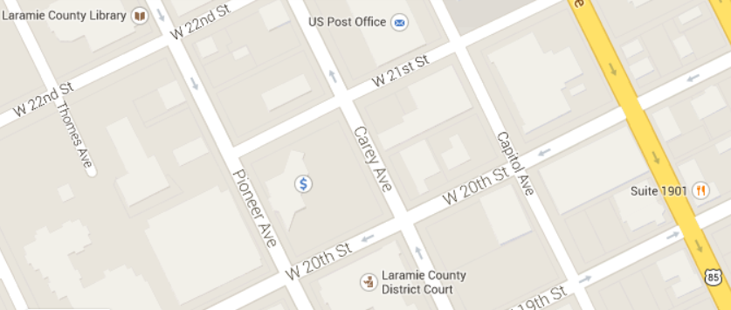
Laramie County Library  Address: 2200 Pioneer Ave, Cheyenne, WY 82001  Phone:(307) 634-3561  THIS IS A ONE WAY STREET. | LARAMIE COUNTY LIBRARY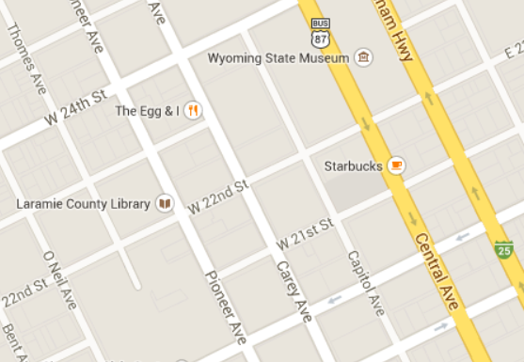
Old West Museum  Address: 4610 Carey Ave, Cheyenne, WY 82001  Phone: (307) 778-7290 | OLD WEST MUSEUM 